**Sequential logic**

* State, Latches and flip-flops (FF)
* Synchronous logic design
* Finite state machines (FSM)

**State:**

* Bistable circuit: no inputs to control the state, only outputs

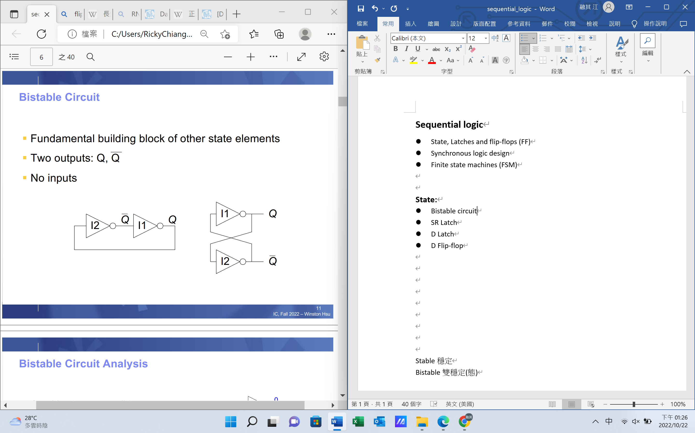

* SR(set/reset) Latch: changed by bistable circuit, two inputs and two outputs

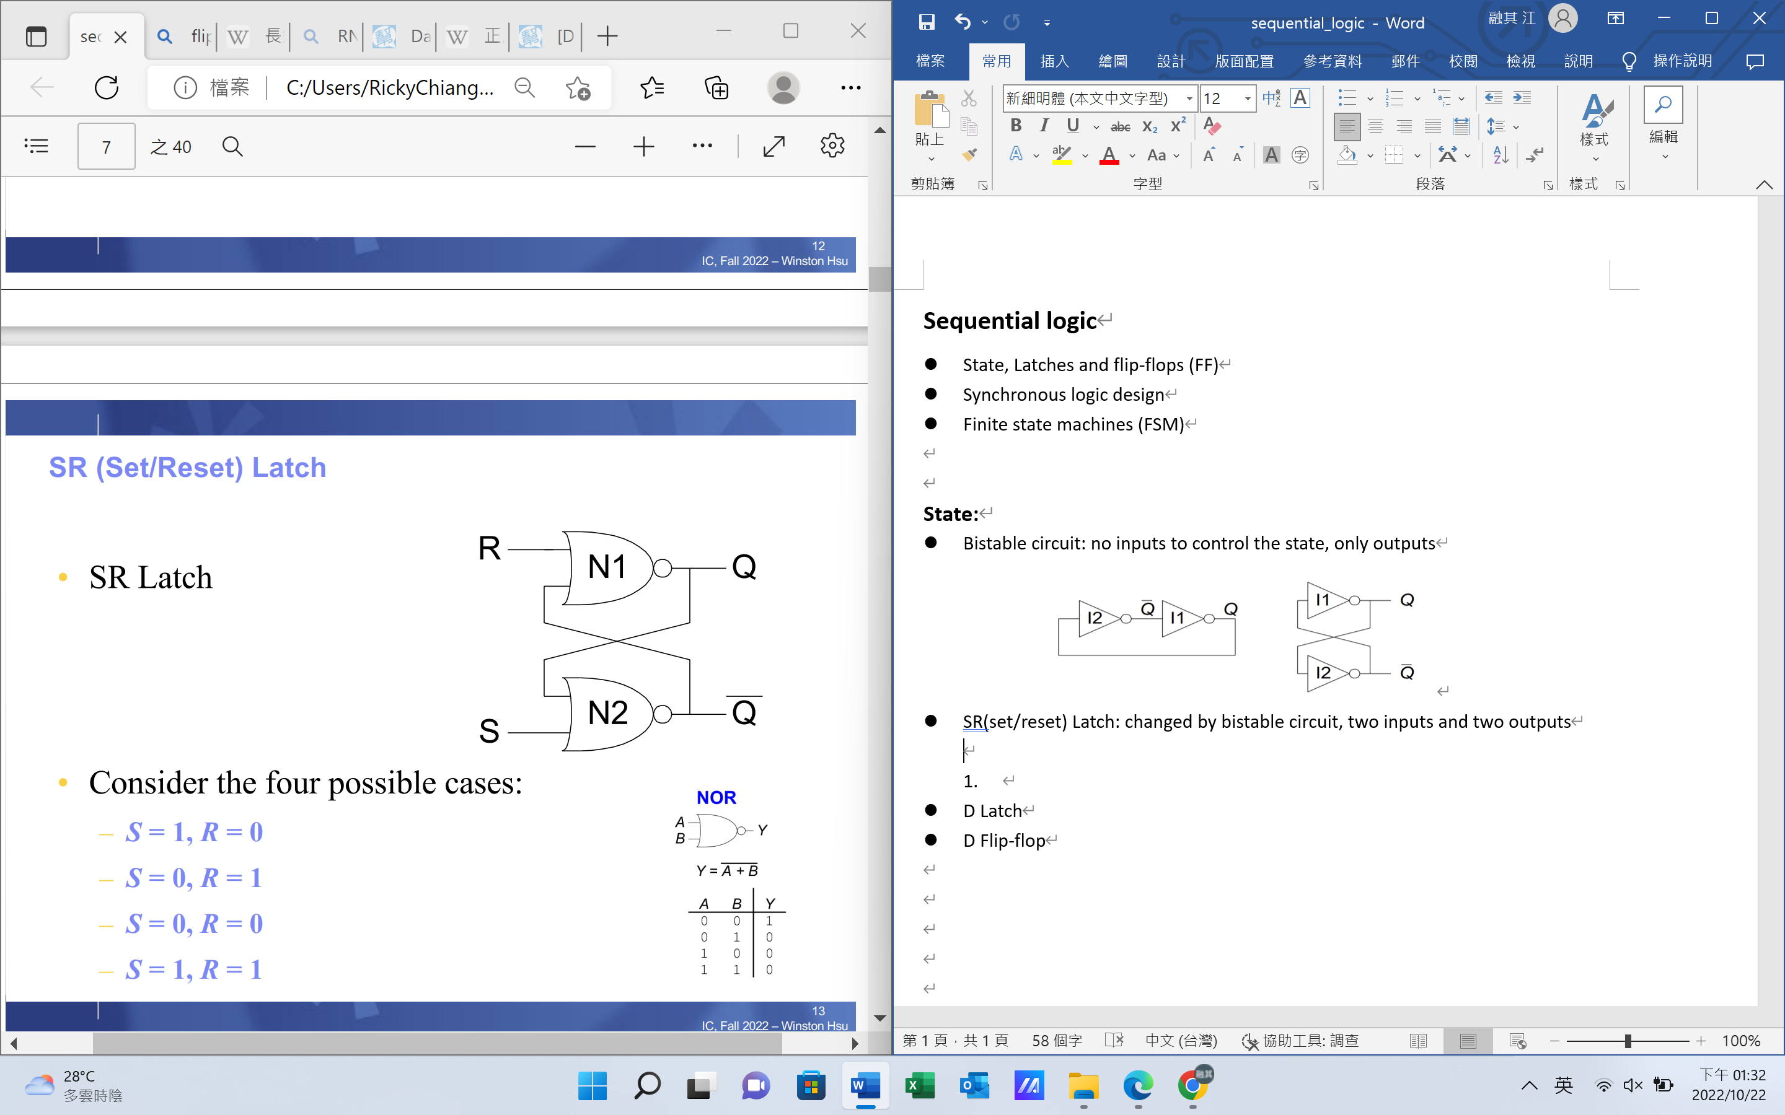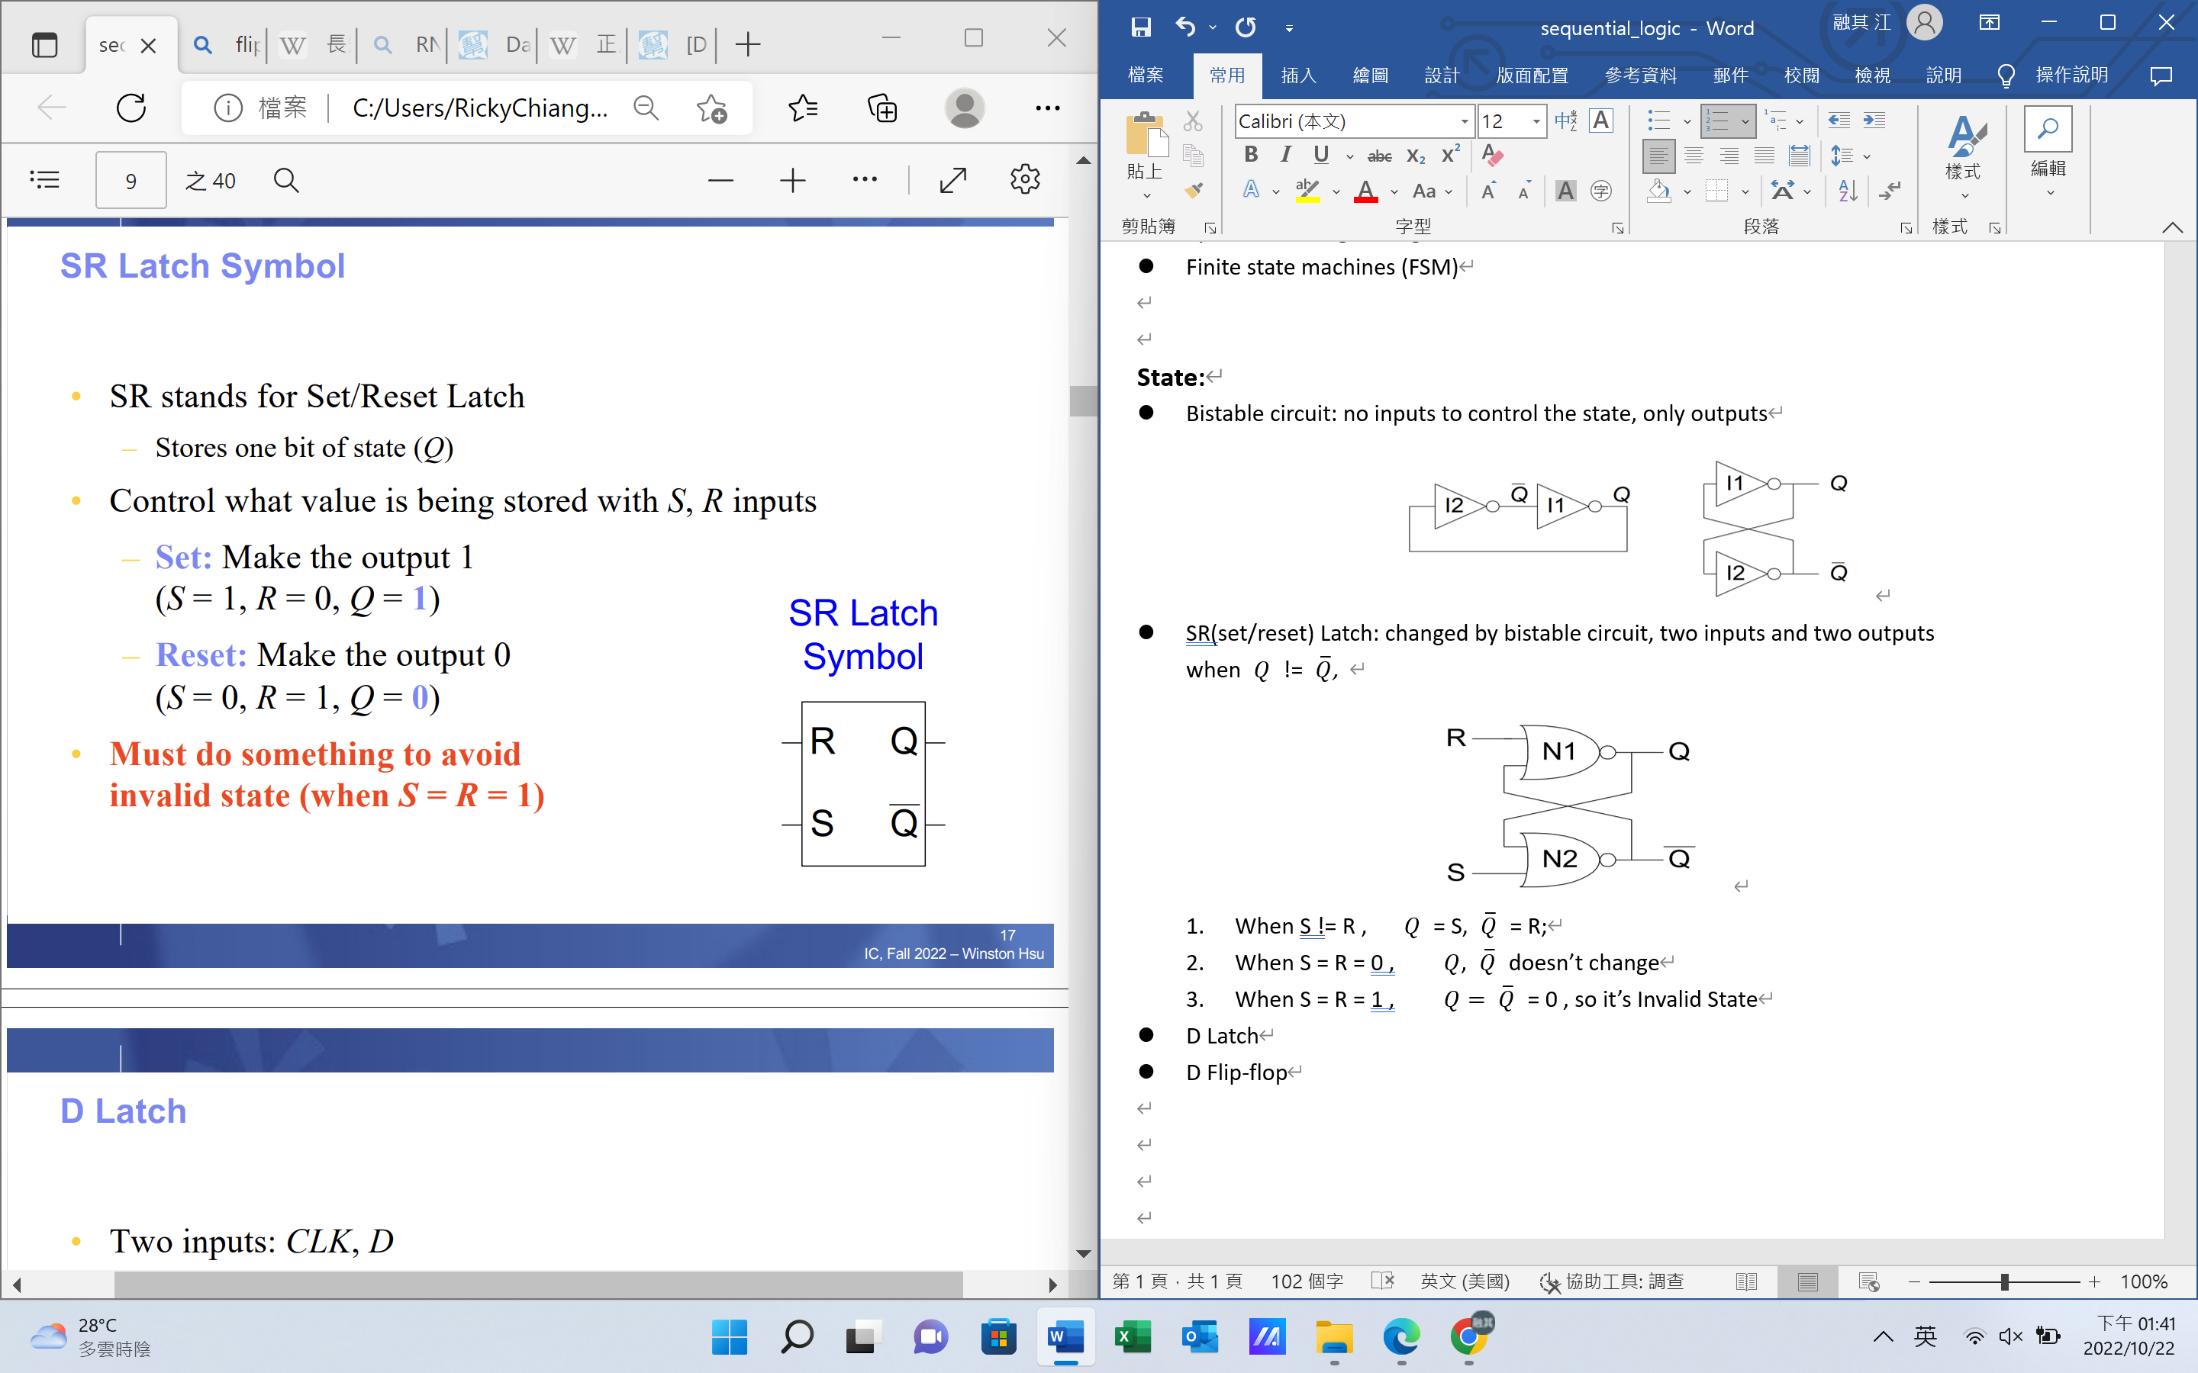

1. When S != R , $Q$ = S, $\overline{Q}$ = R;
2. When S = R = 0 , $Q$, $\overline{Q}$ doesn’t change
3. When S = R = 1 , $Q= \overline{Q}$ = 0 , so it’s Invalid State, we have to avoid it

* D Latch: two inputs (CLK, D), changed by SR Latch, CLK decide if Q change or holds previous value, if CLK = 1, then D = Q and $\overline{D}= \overline{Q}$

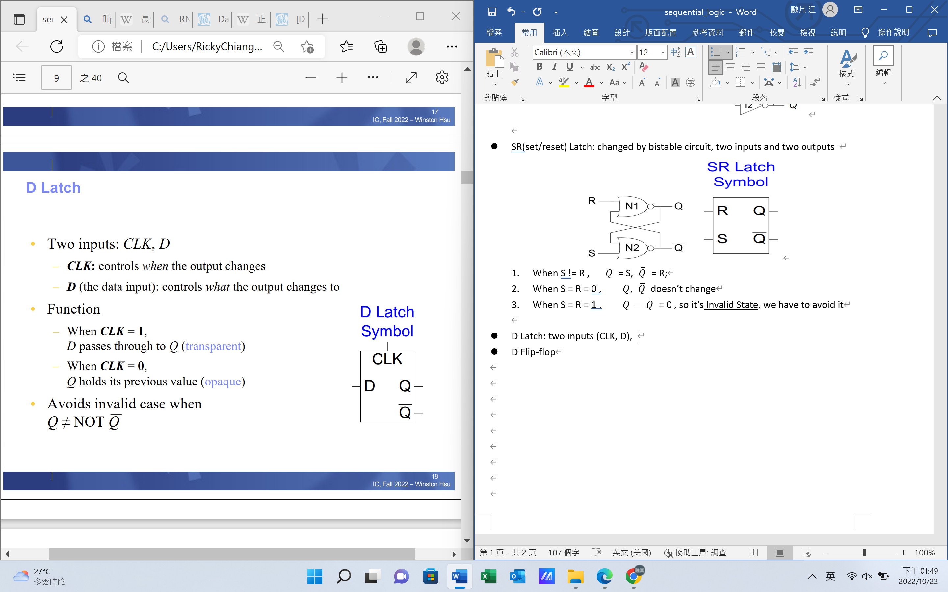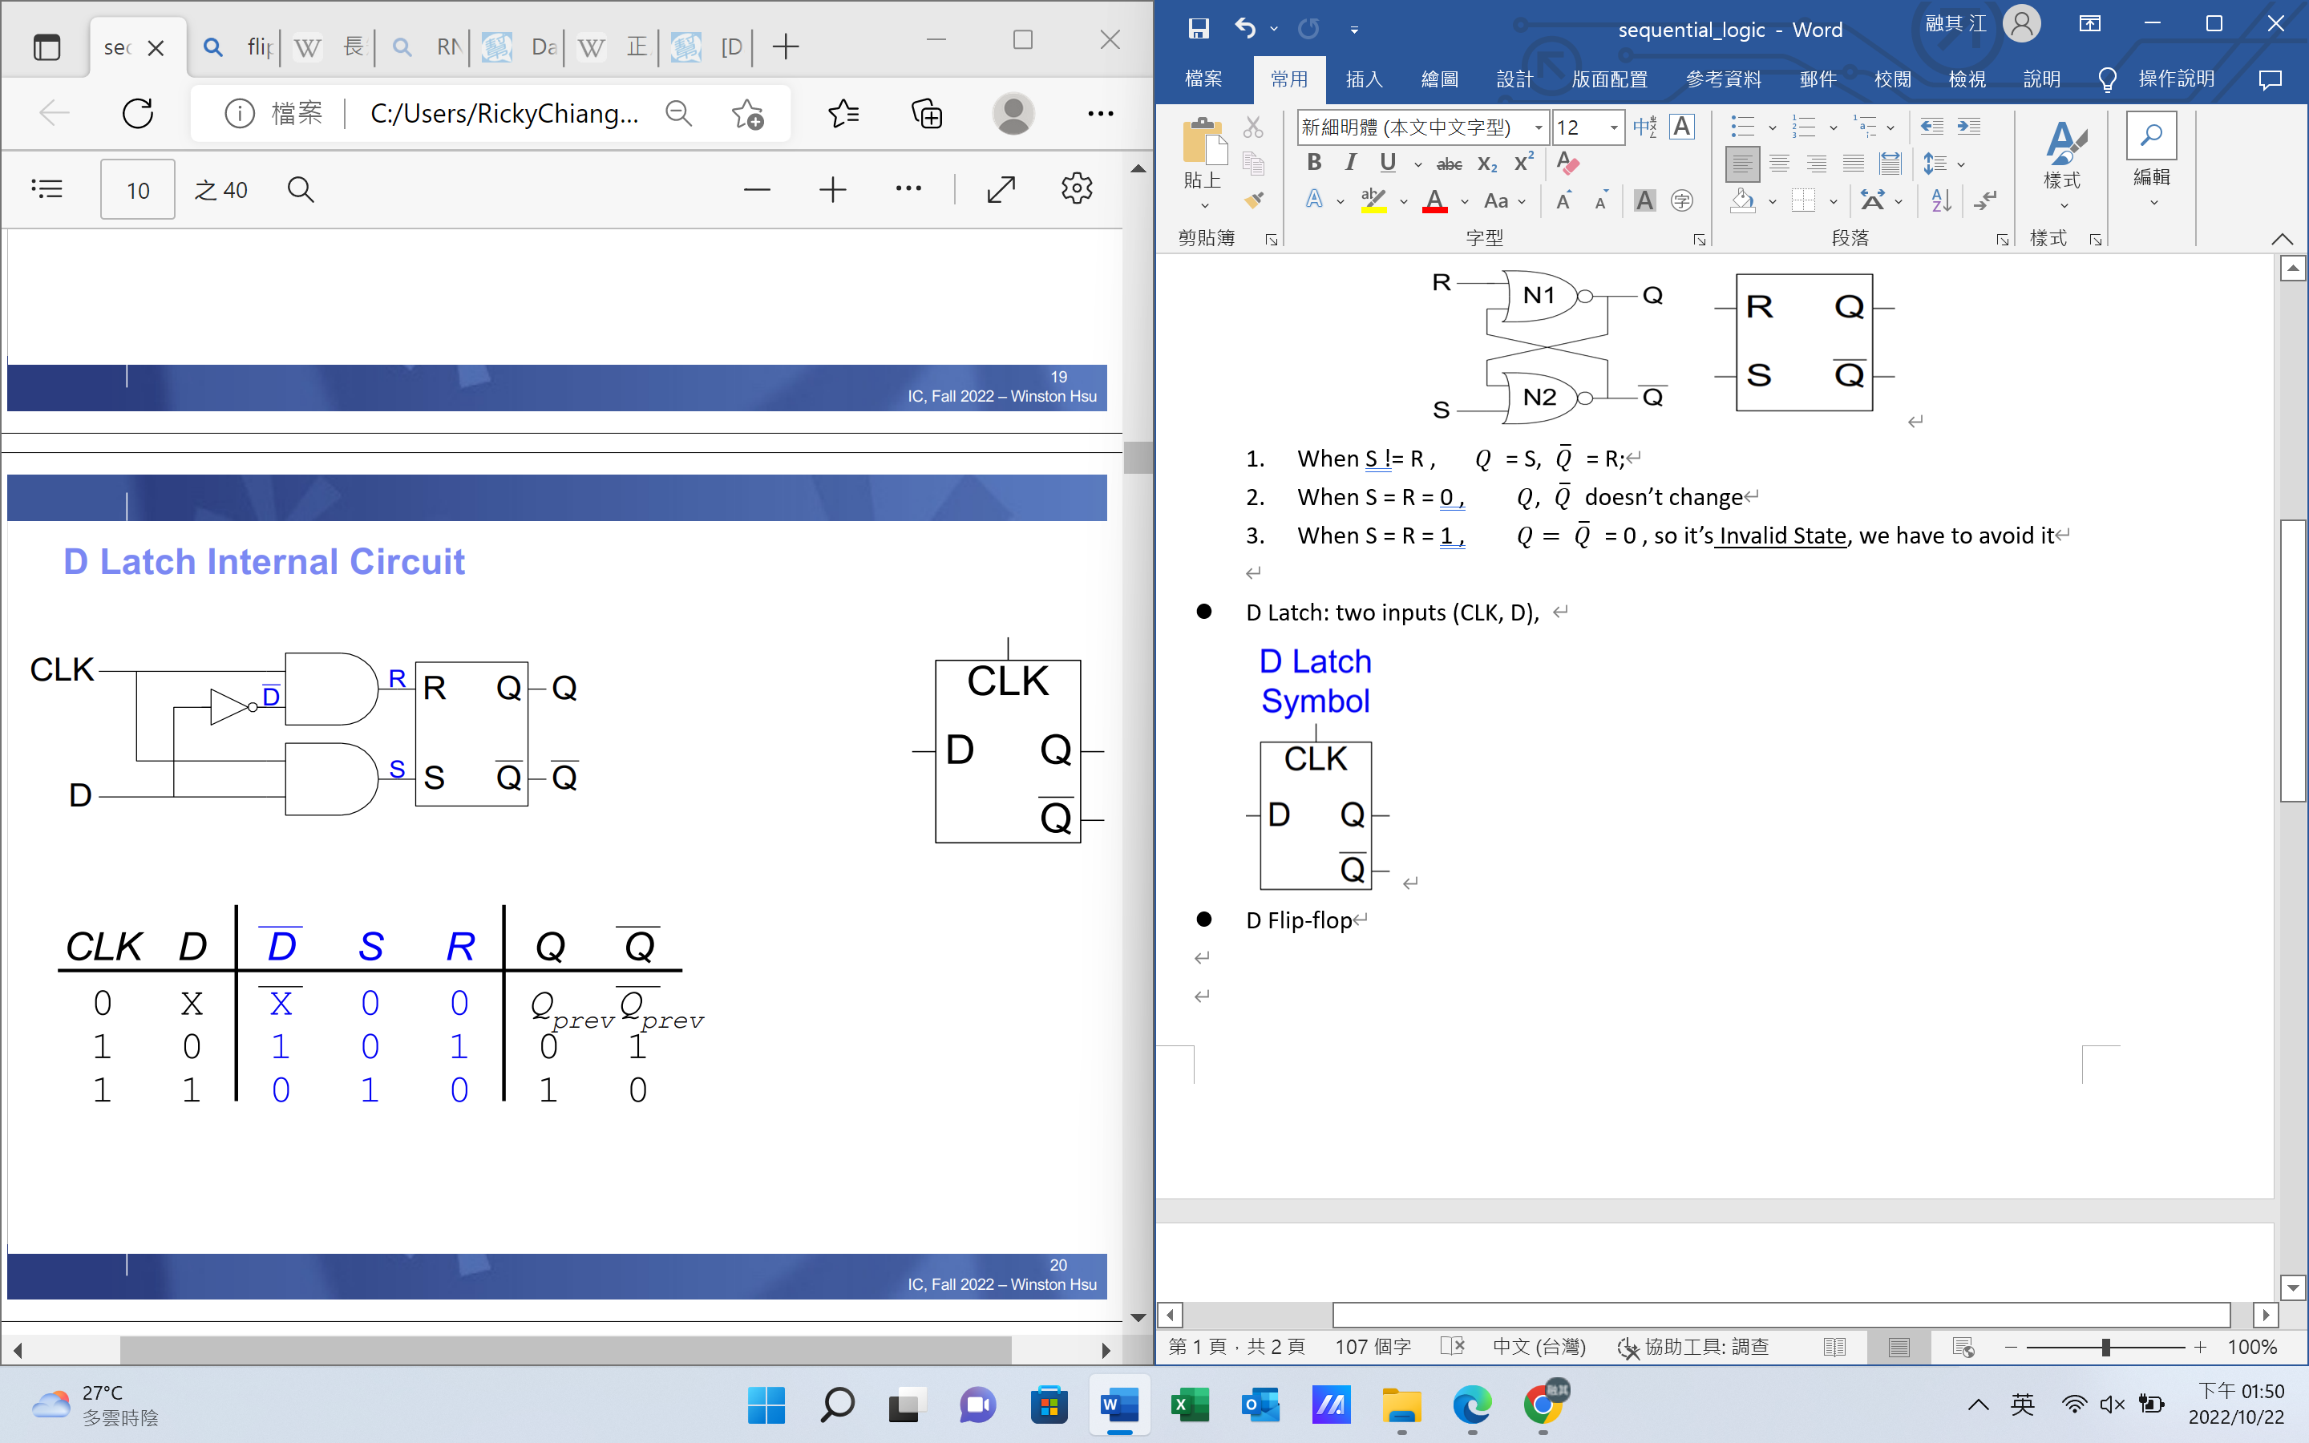

* D Flip-Flop: inputs and outputs are same as D Latch, changed by D Latch, each Q and $\overline{Q}$ change when its CLK = 1.

So only when CLK = 0 🡪 CLK = 1, Q can output.

D can always input, but the left Q can get the value when CLK = 0.

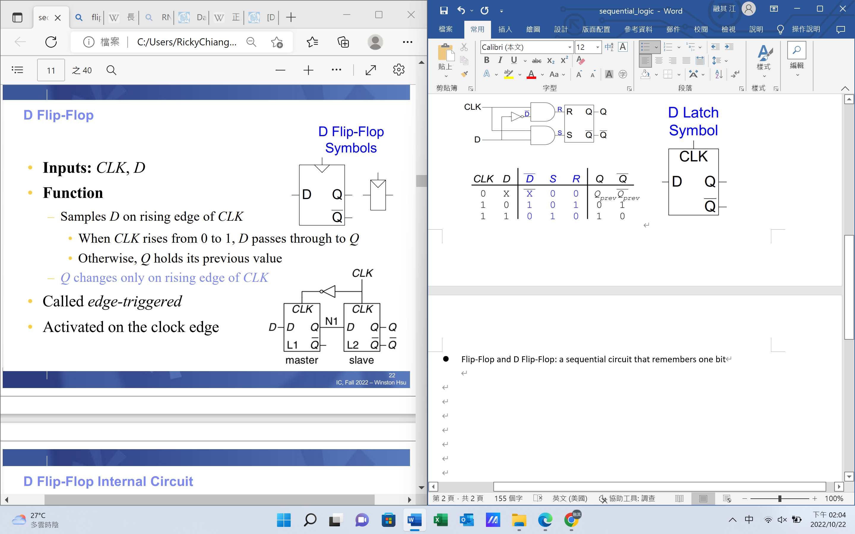

* Enabled Flip-Flop: 3 inputs(CLK, D, EN), only output Q, changed by D Flip-Flop,

D would change when EN = 1, or input would be Q itself.

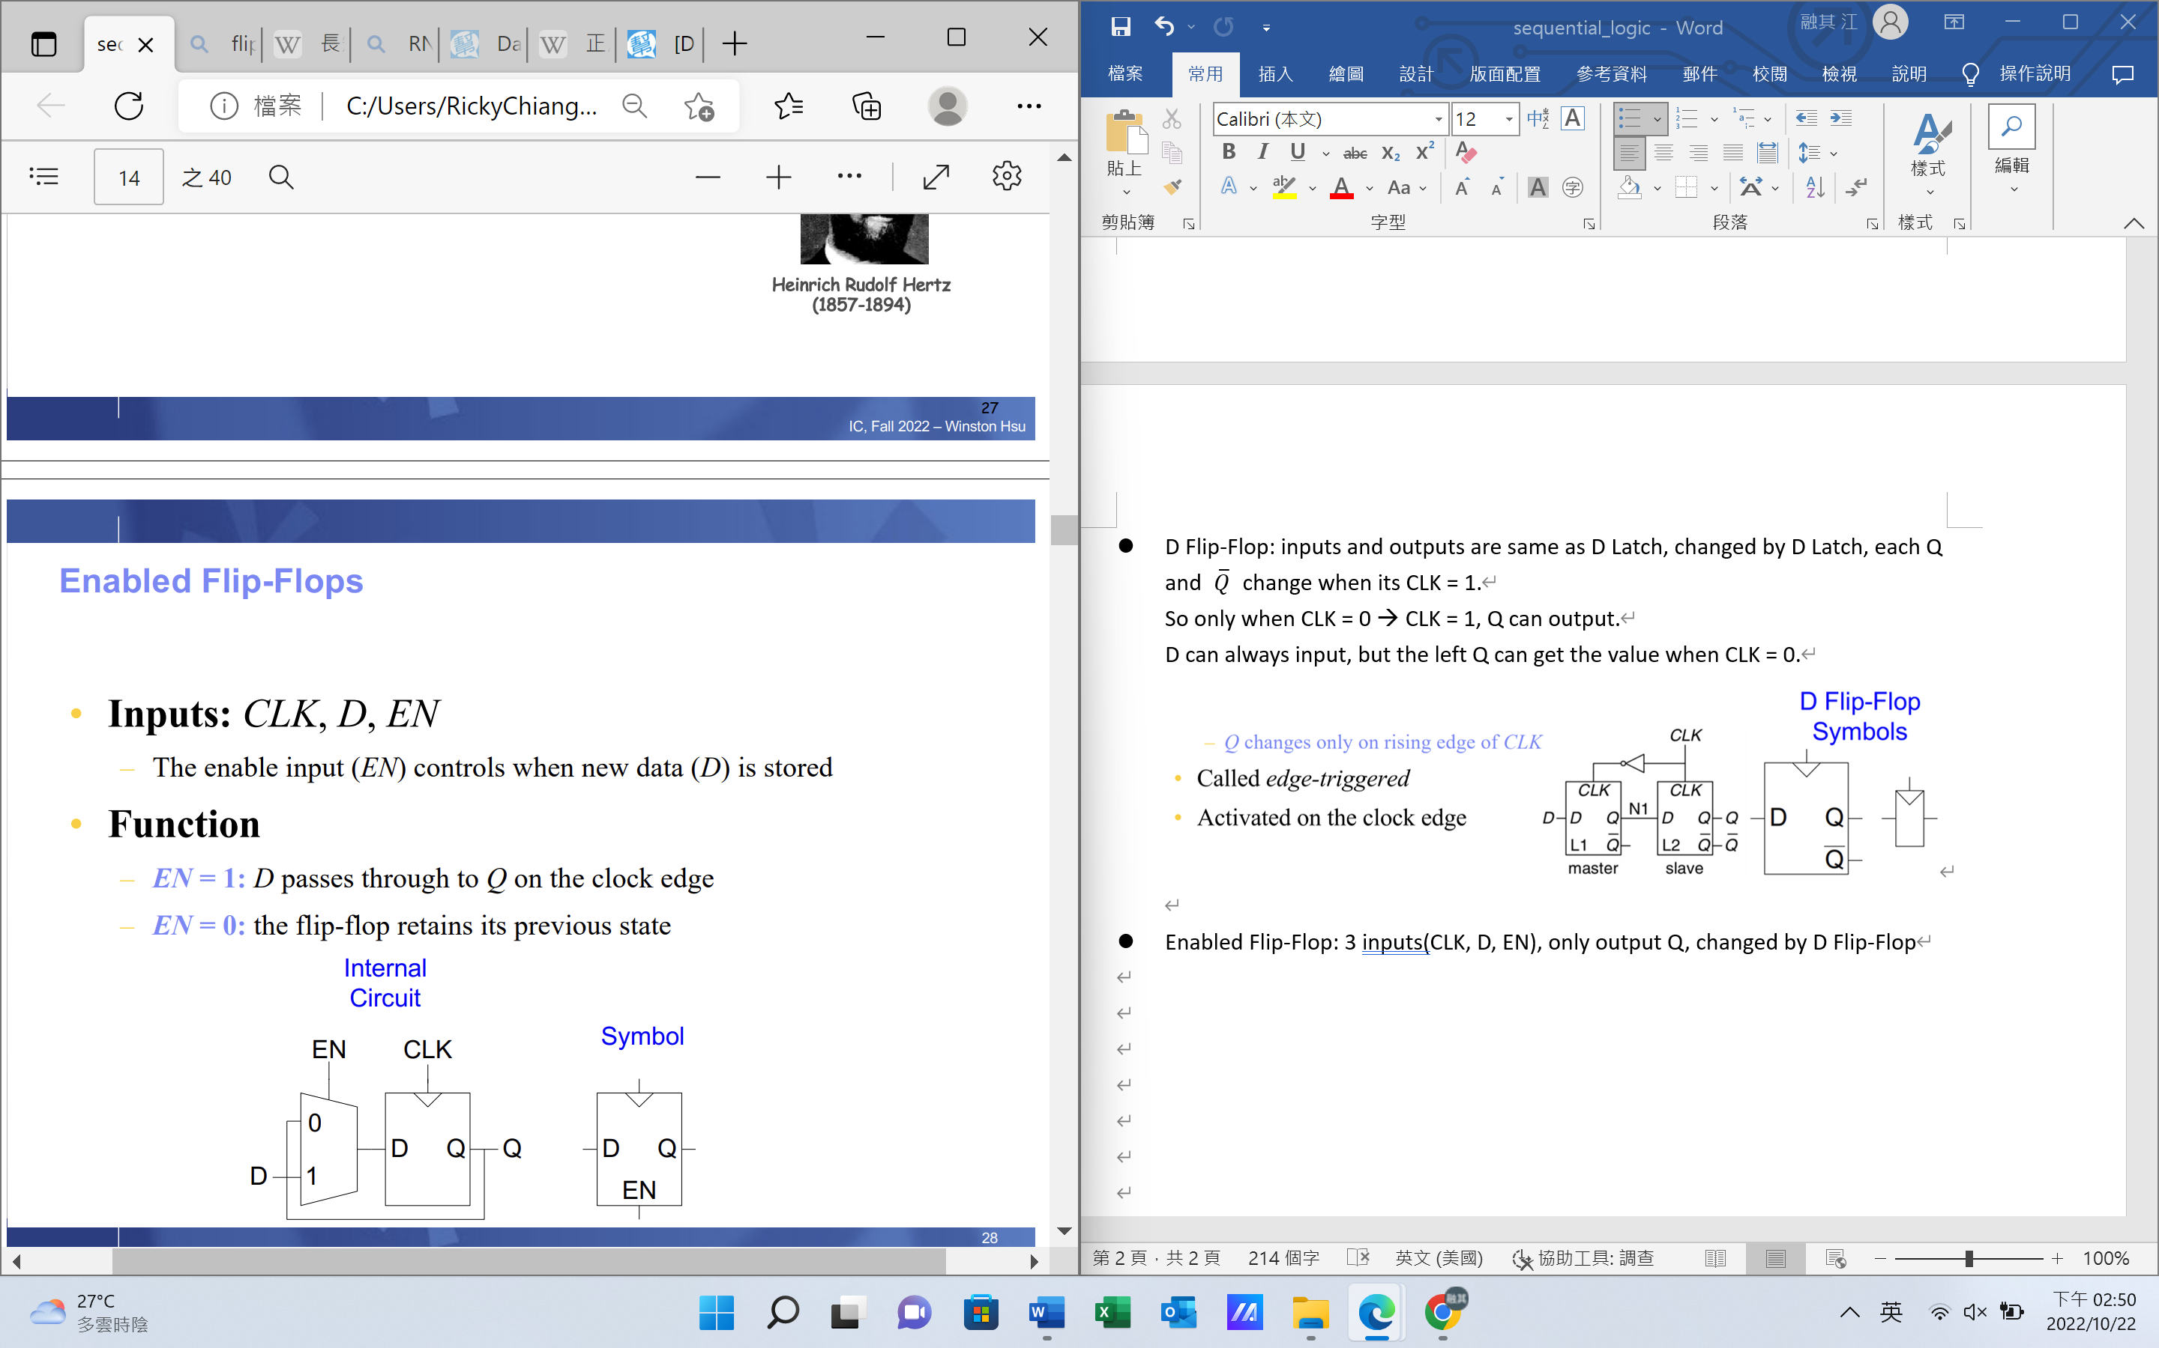

* Resettable Flip-Flops: 3 inputs(CLK, D, Reset)

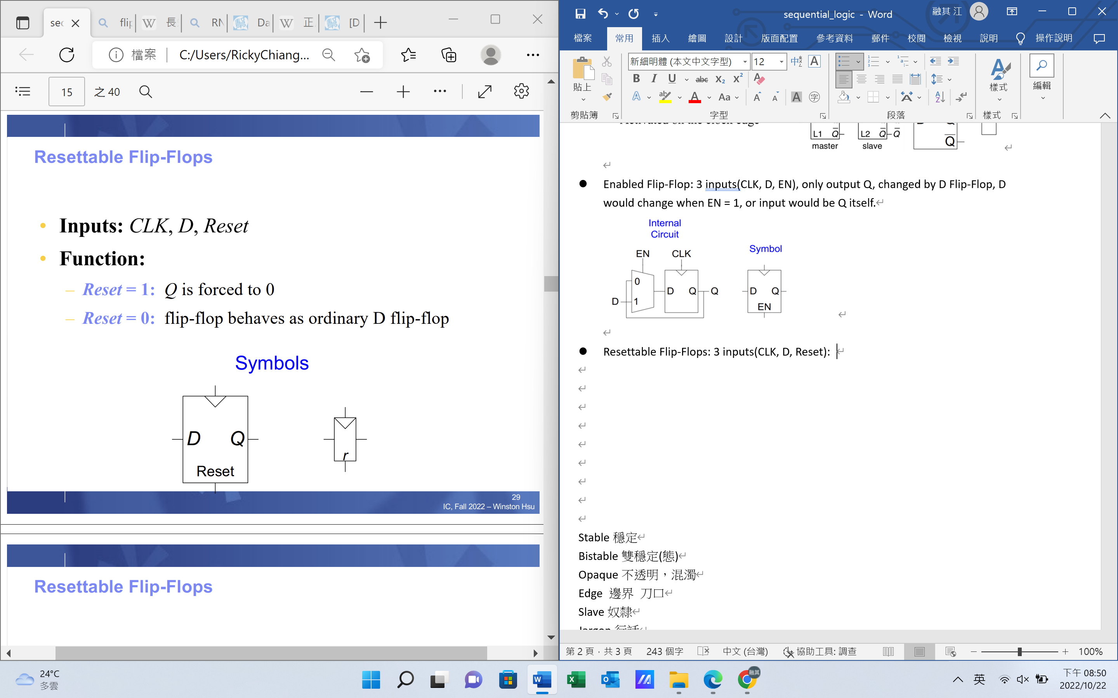 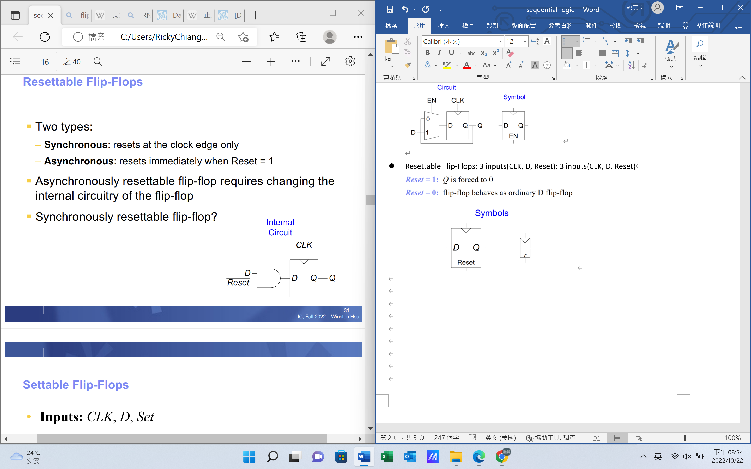

* Settable Flip-Flops: 3 inputs(CLK, D, Set)(only forced number different to reset)

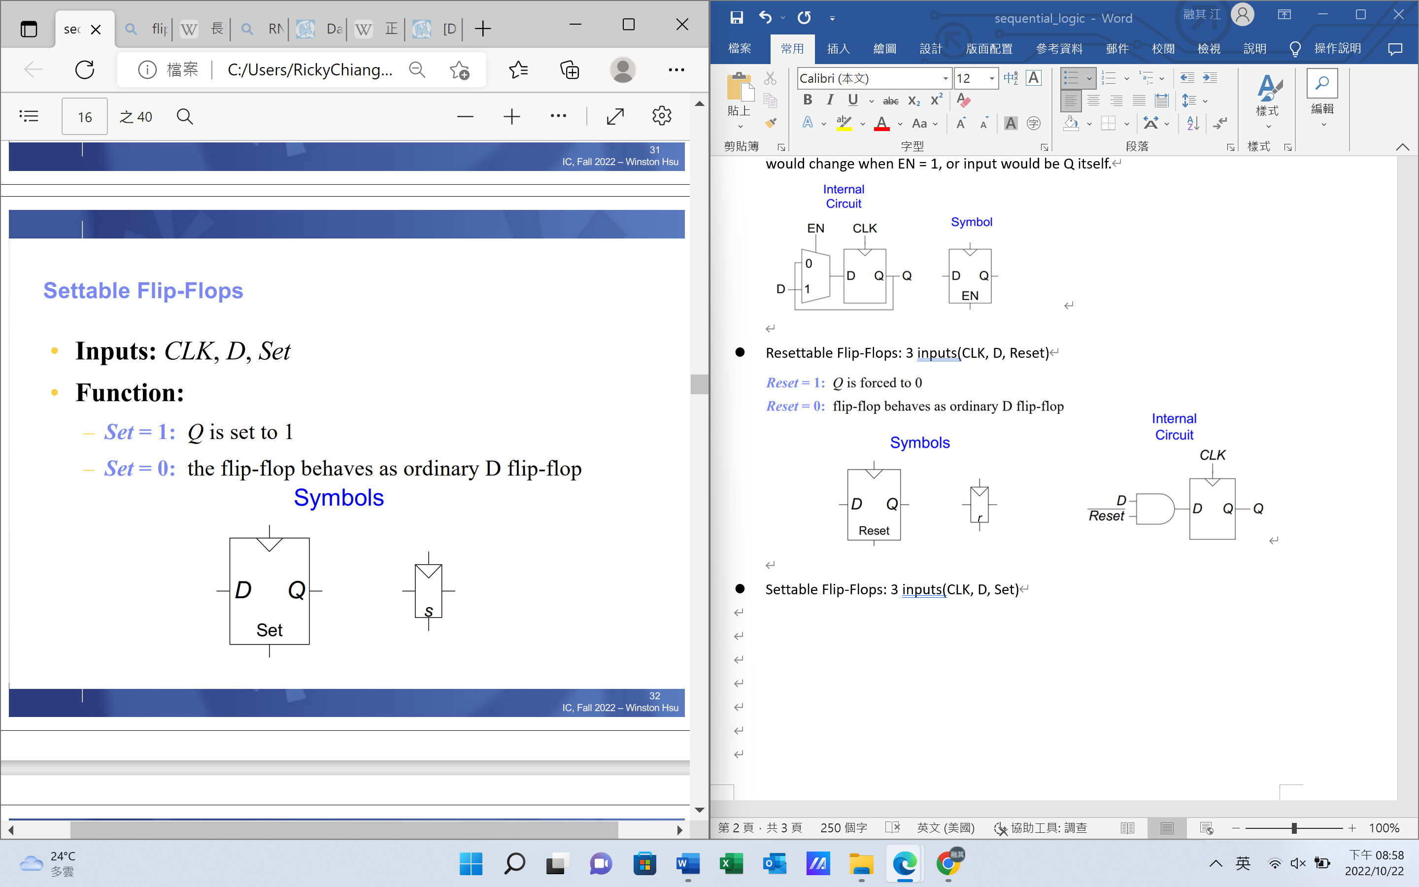

* Registers (4 Bit): 1 byte = 8 bit

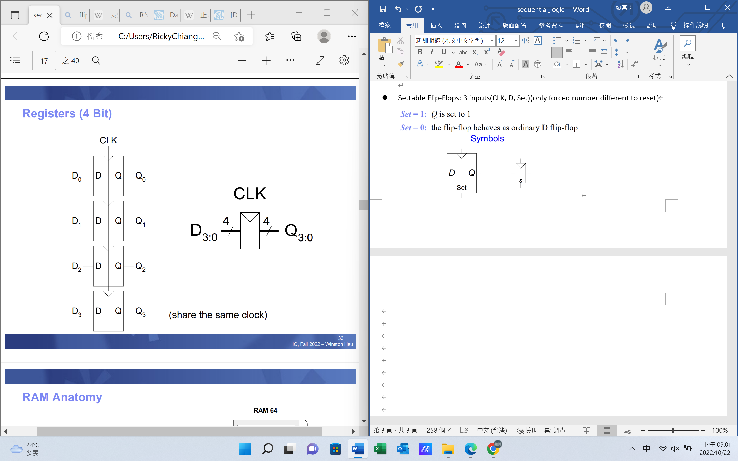

Register file:

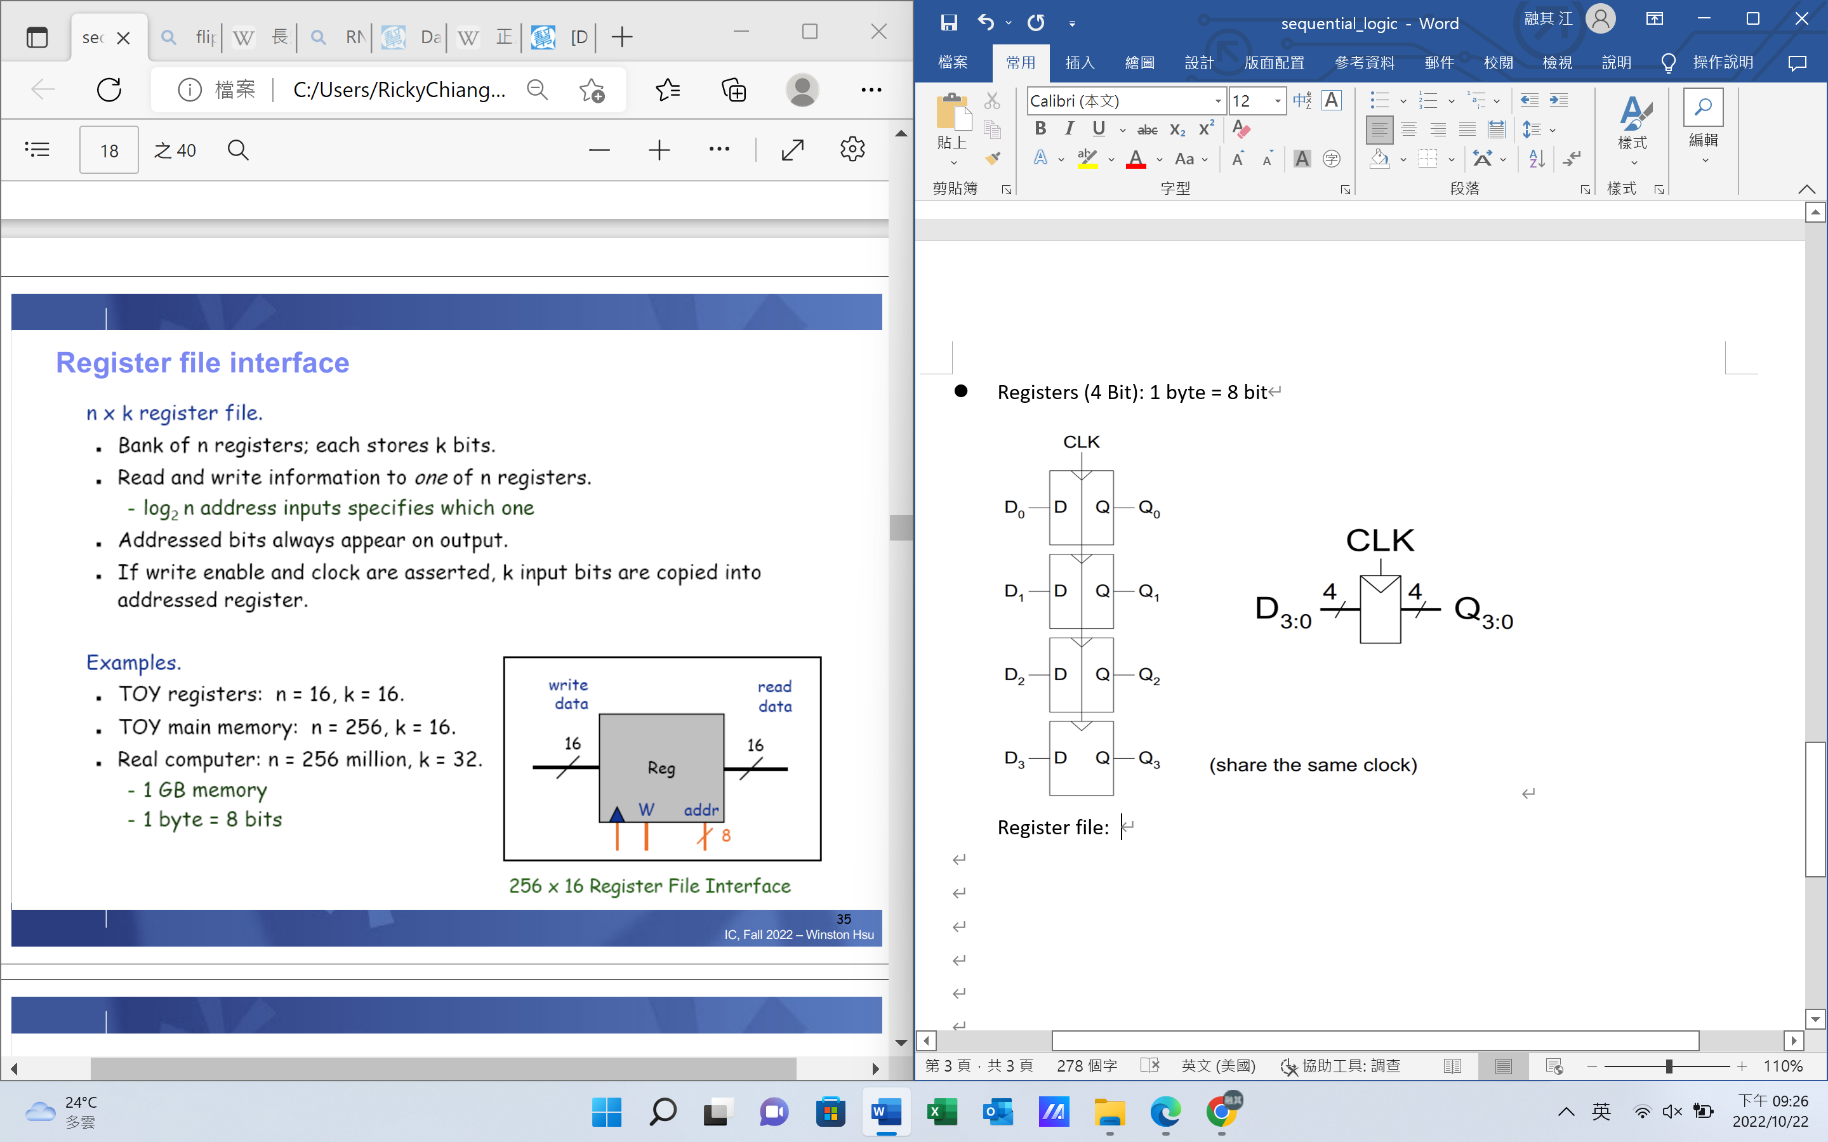

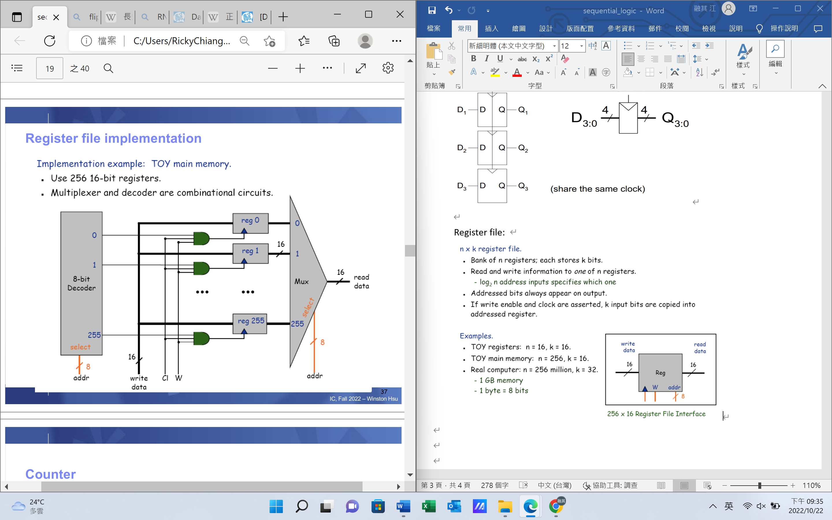

* (back to)Sequential logic

Example: (assume 1 ns delay)

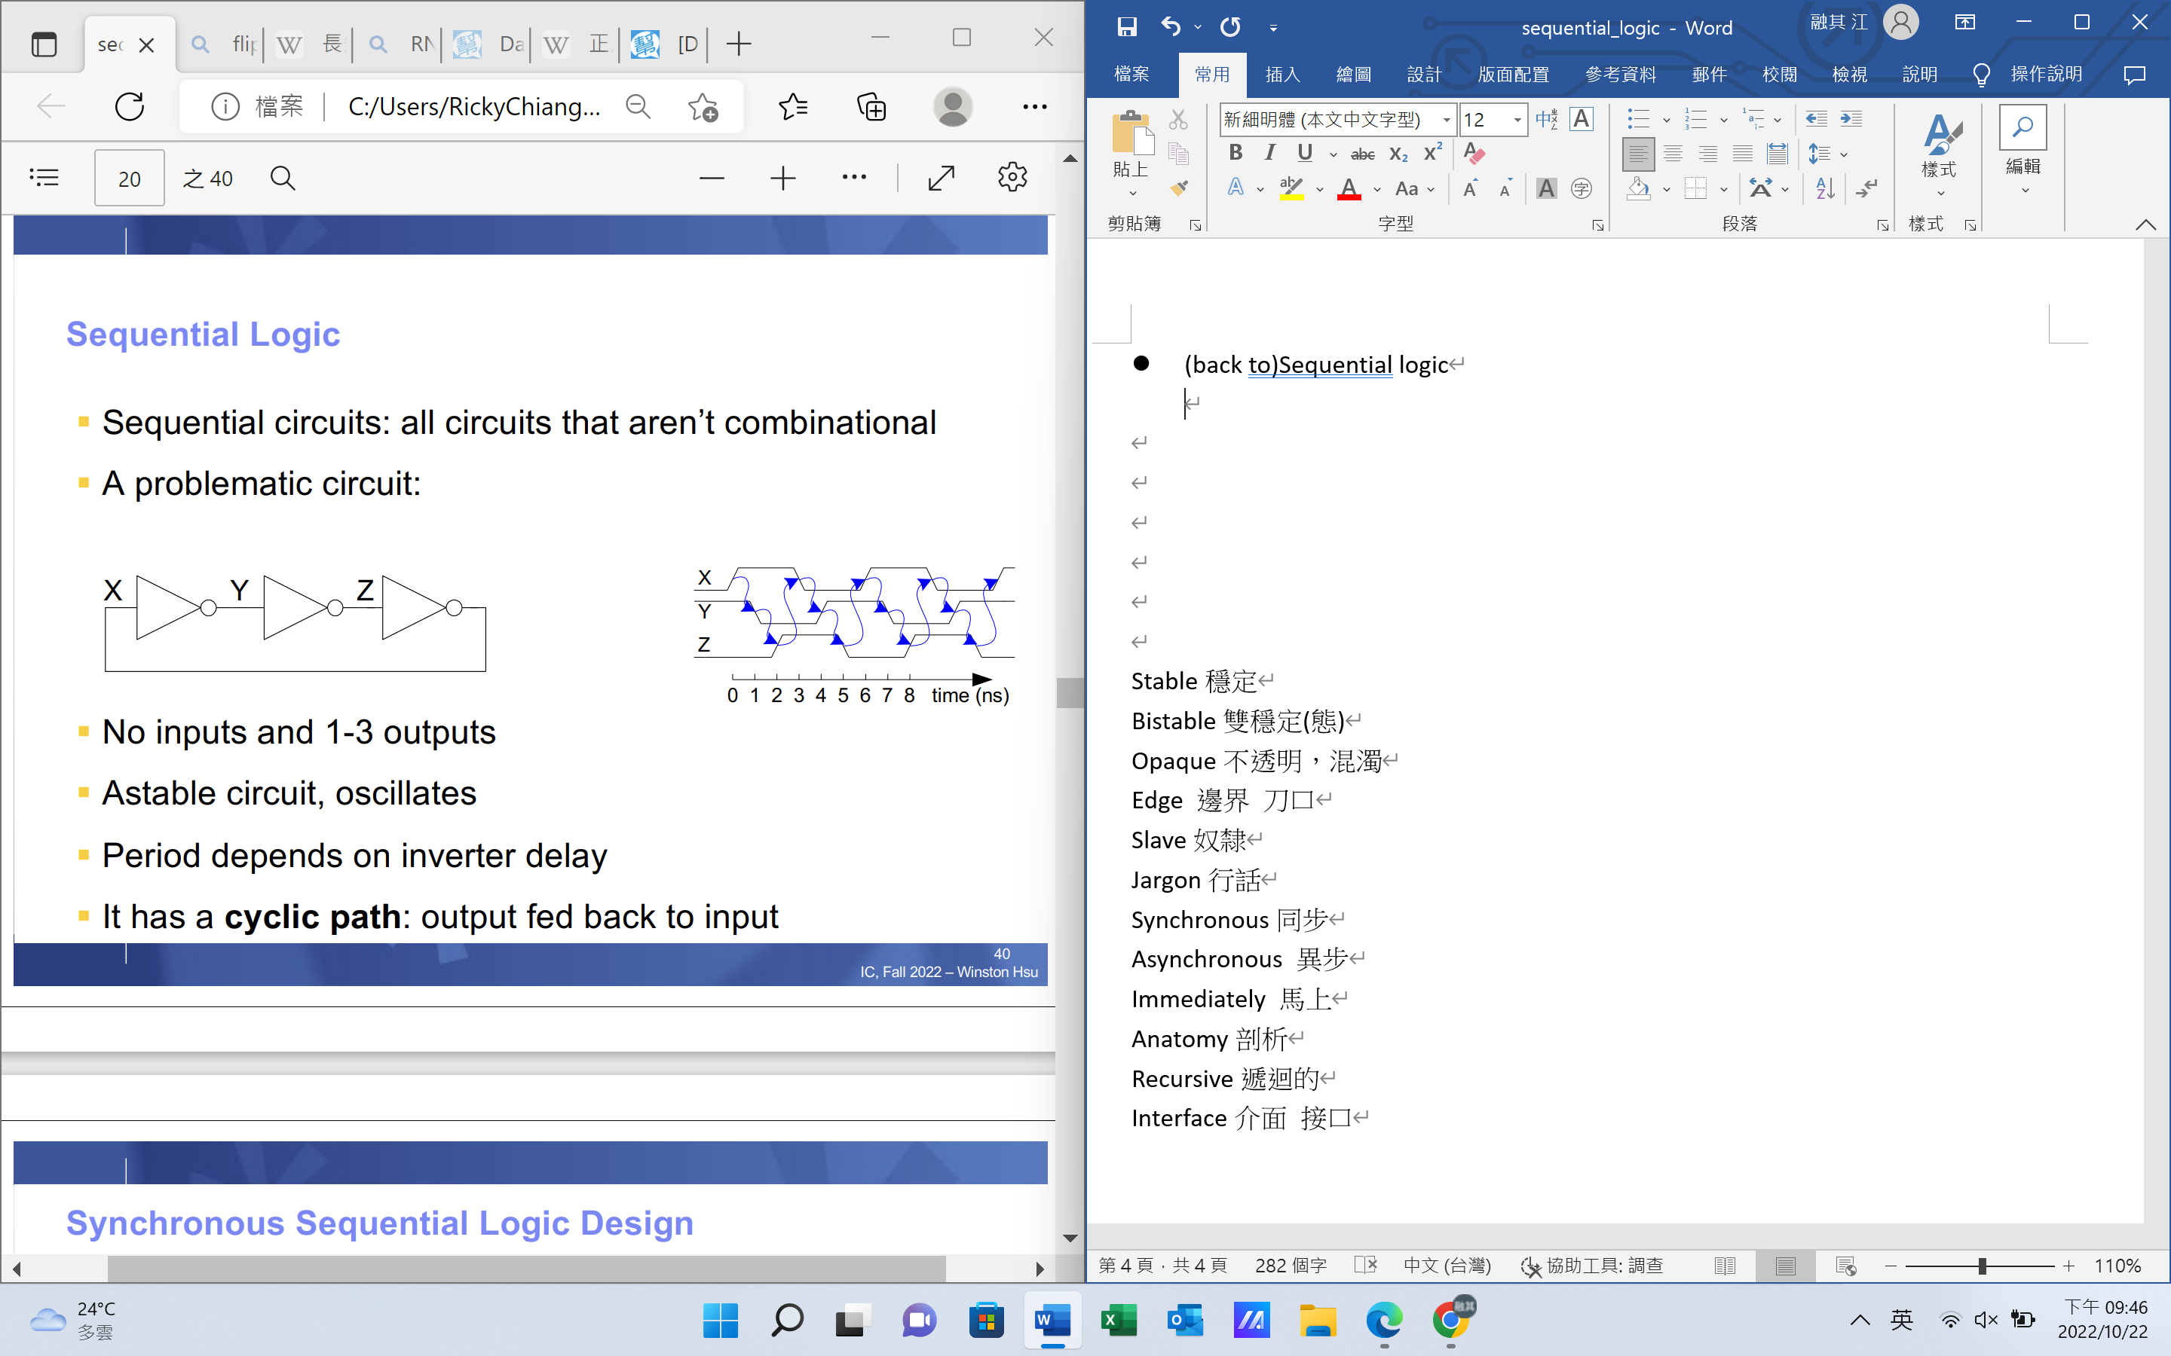

* Synchronous Sequential logic design

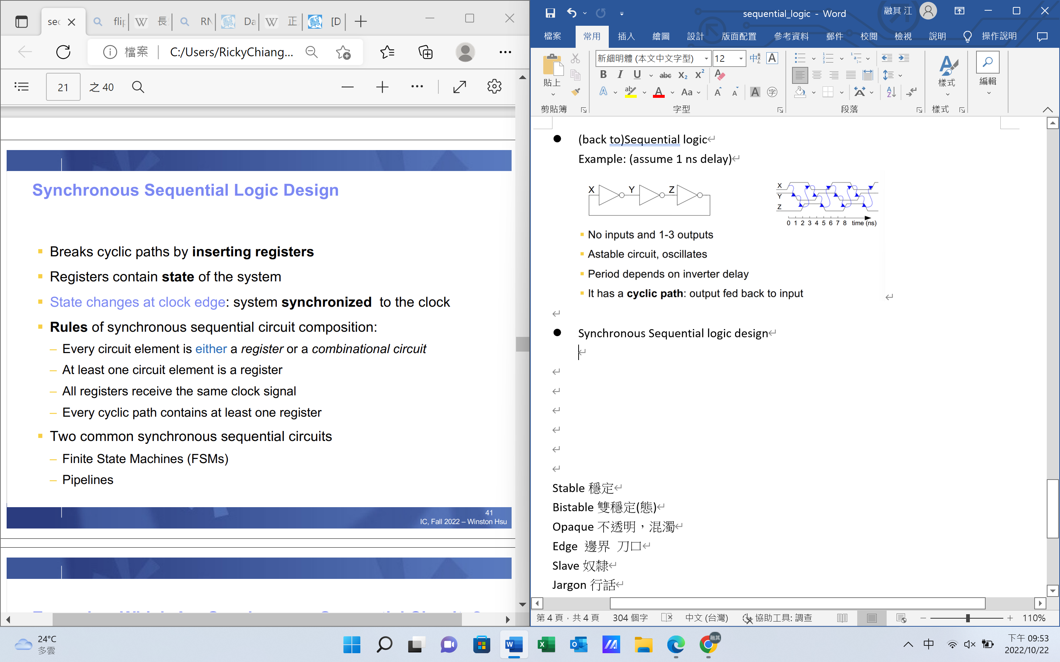

* **Finite State Machine (FSM)**:

consist of state register and combinational logic

next state: determined by current state and inputs

1. Moore FSM: outputs depend on current state
2. Mealy FSM: outputs depend on current state and inputs

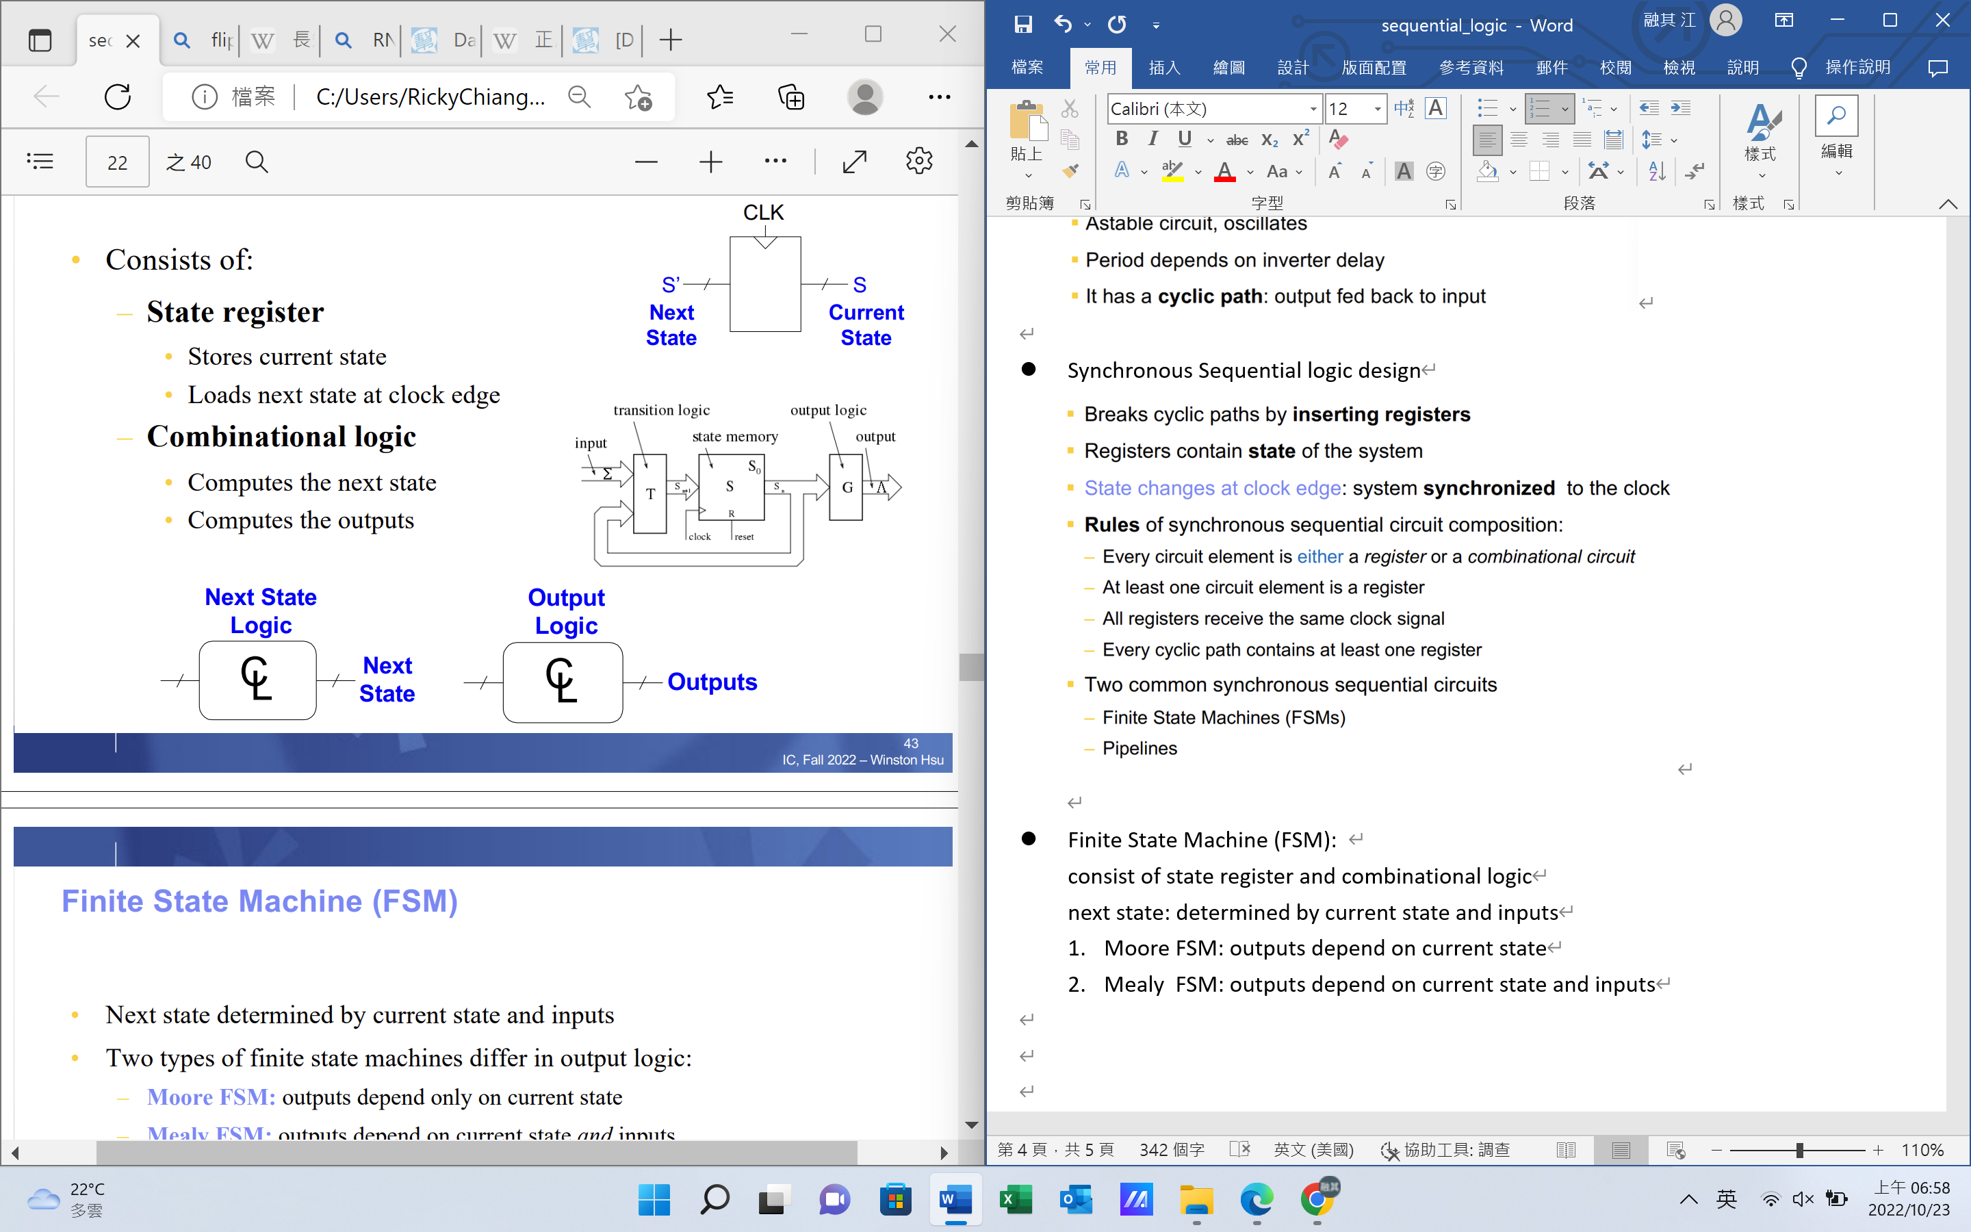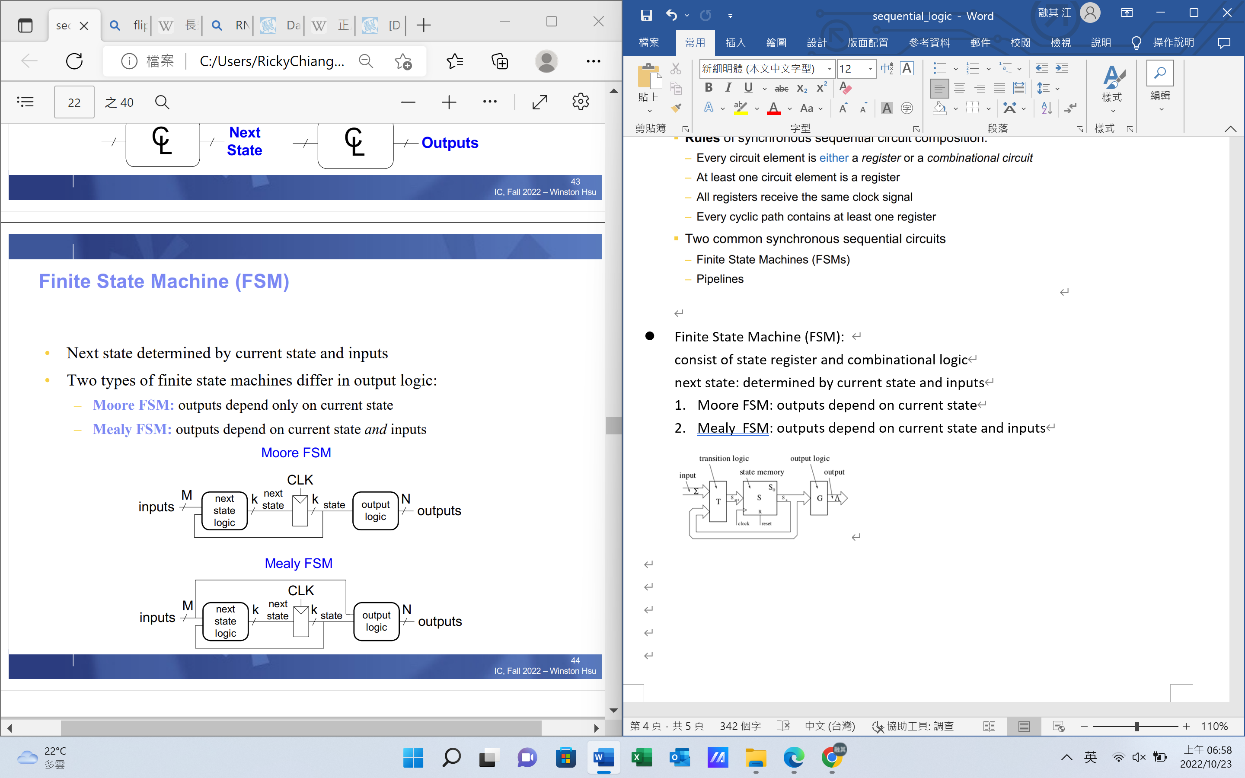

* Example of FSM(easy):

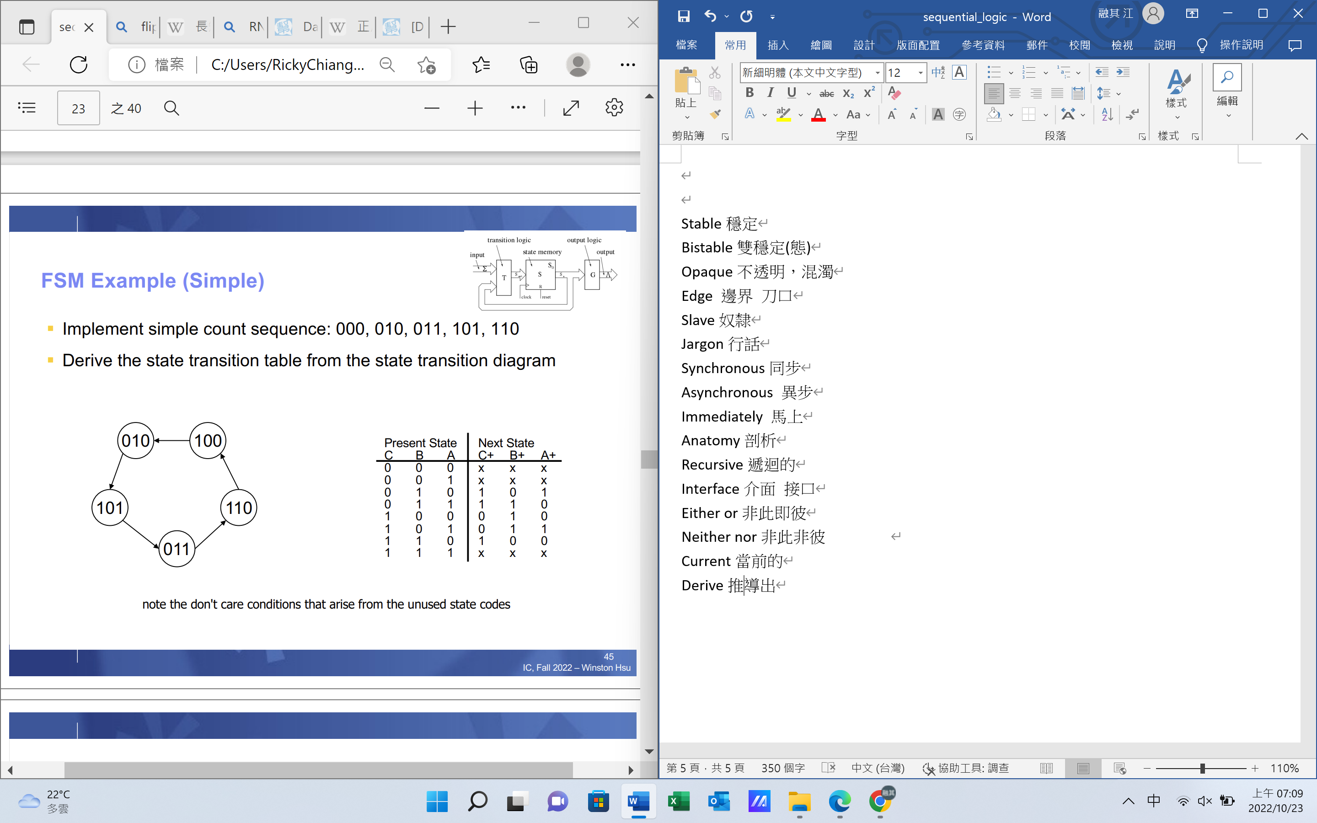

* Example of FSM(Traffic light):

**Input:** Traffic sensors TA, TB (1 if there is traffic), and CLK and Reset

**Output:** Lights LA, LB

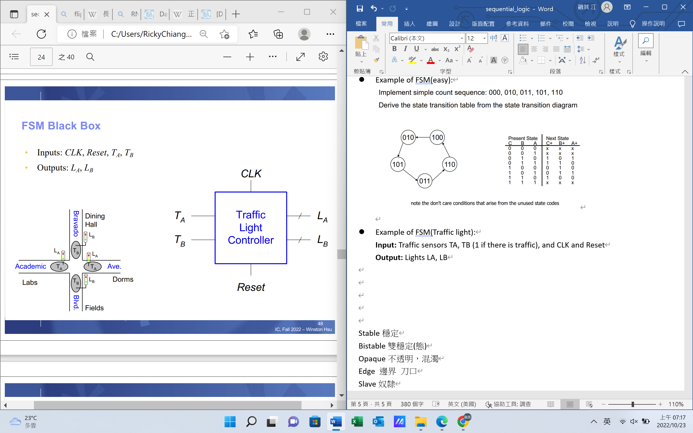

**State transition diagram:**

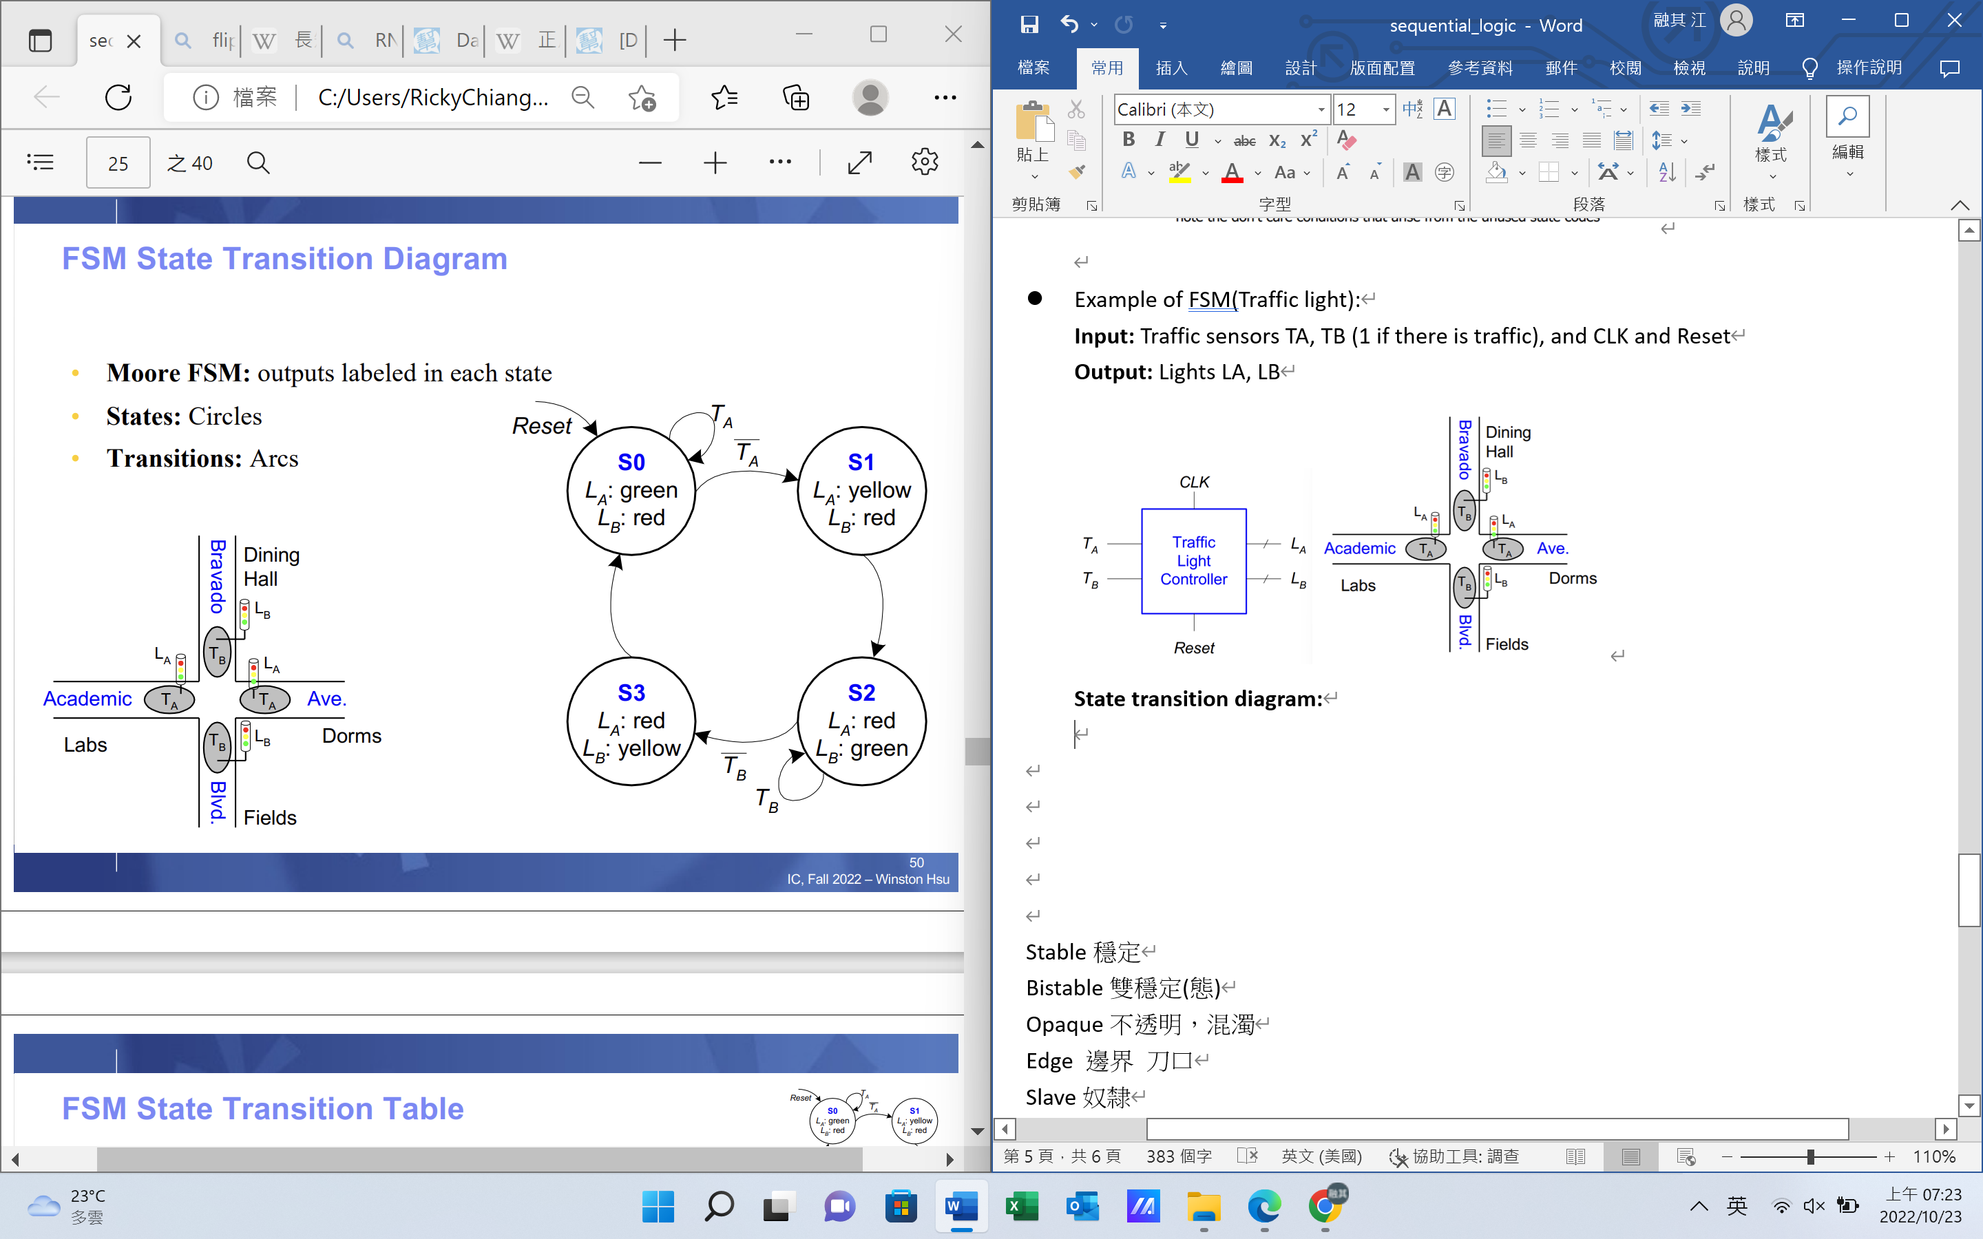

**State transition table** and **Encoded State transition table(無視reset):**

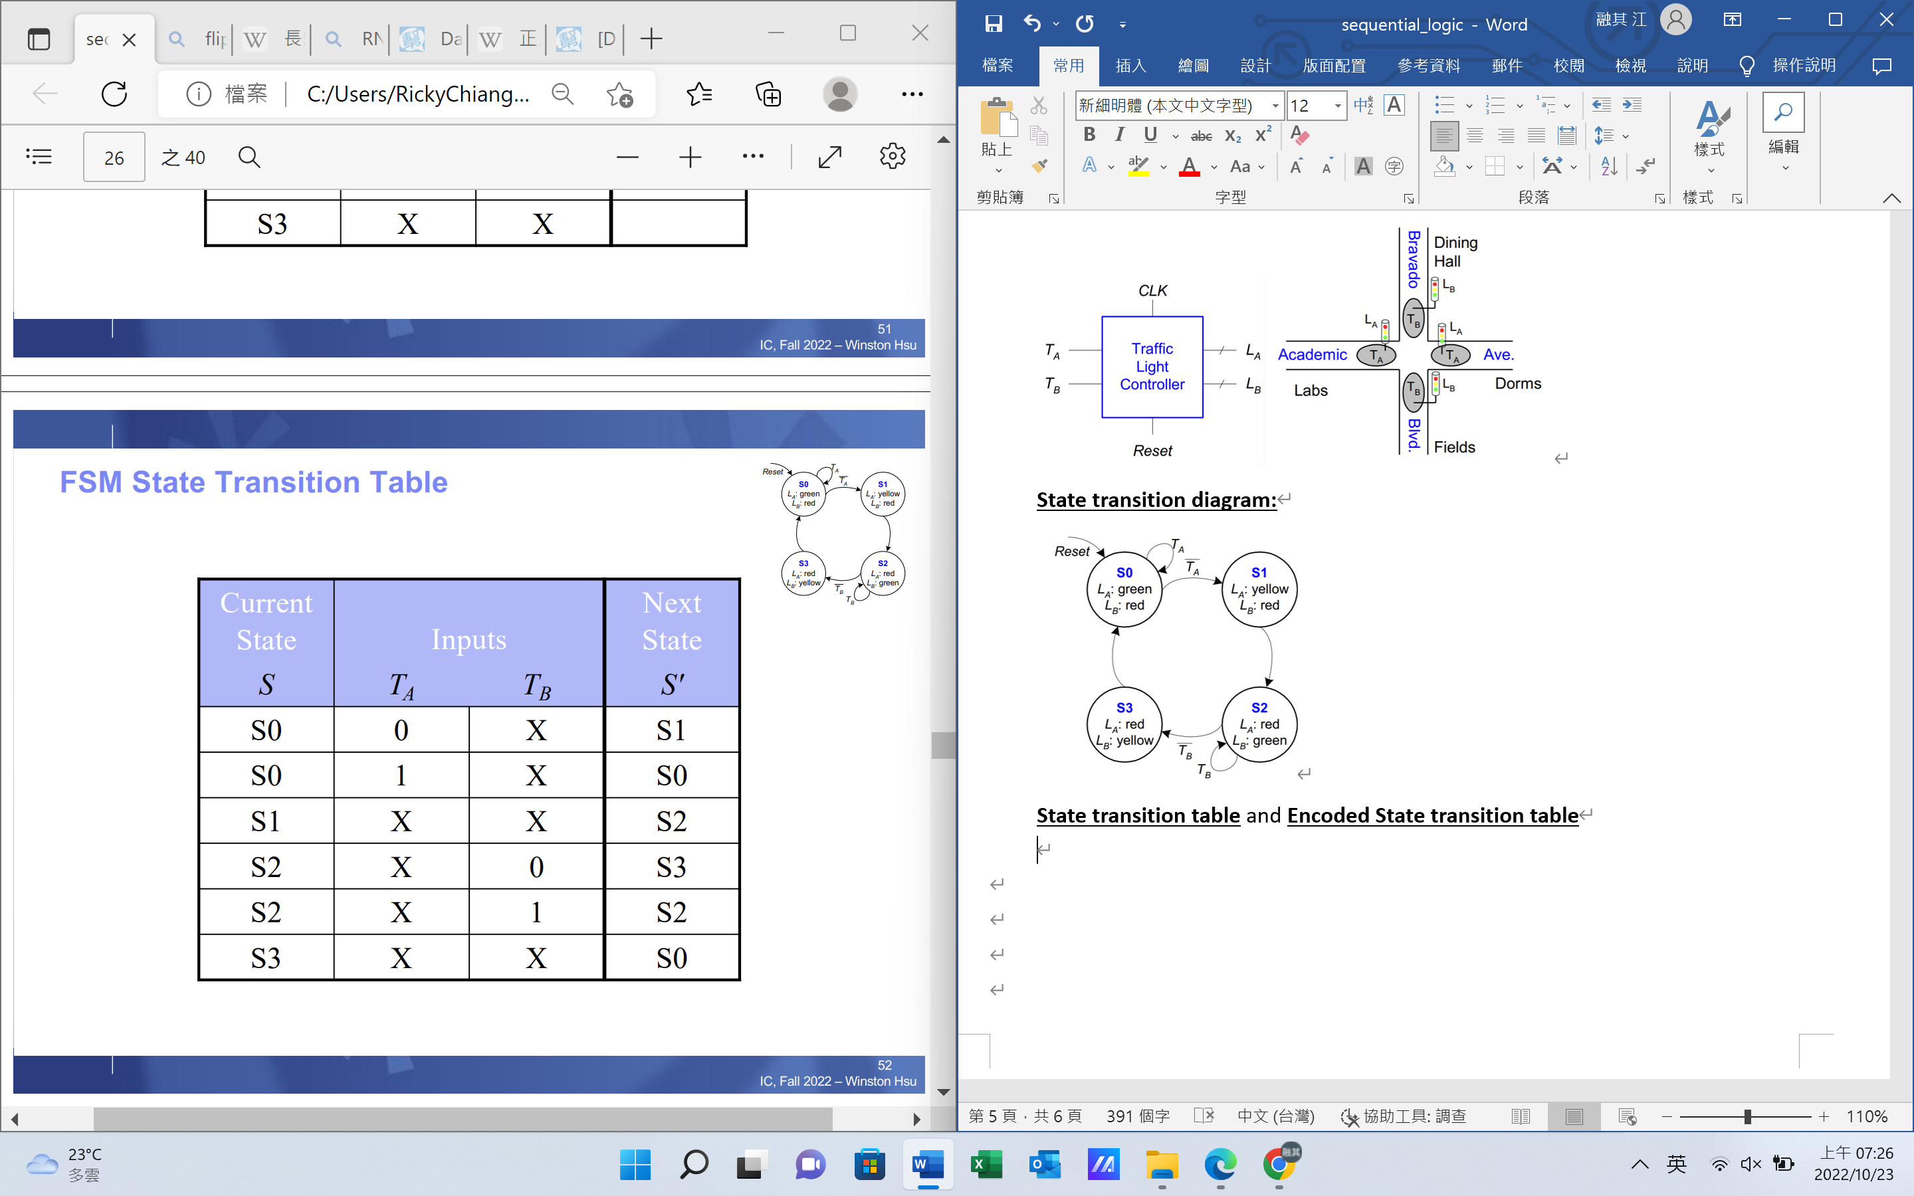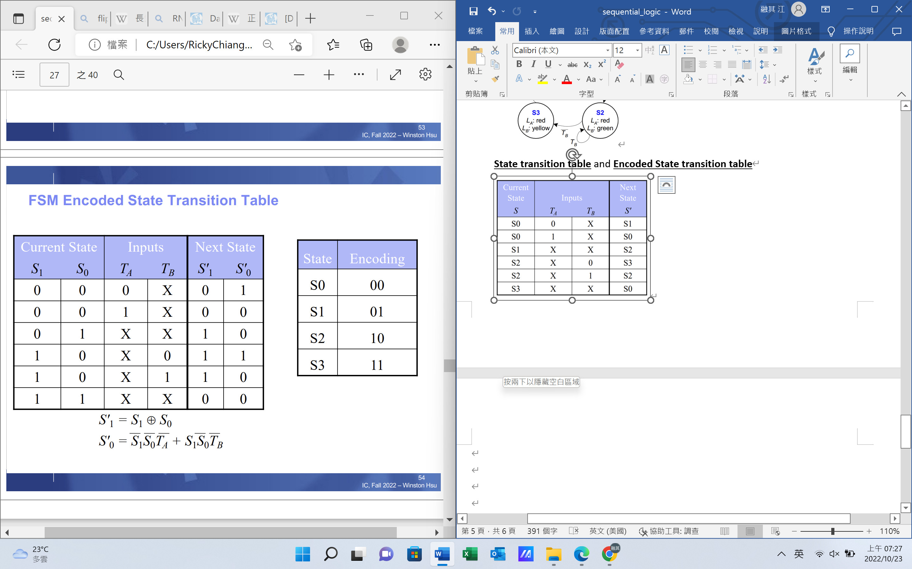

**Output table:**

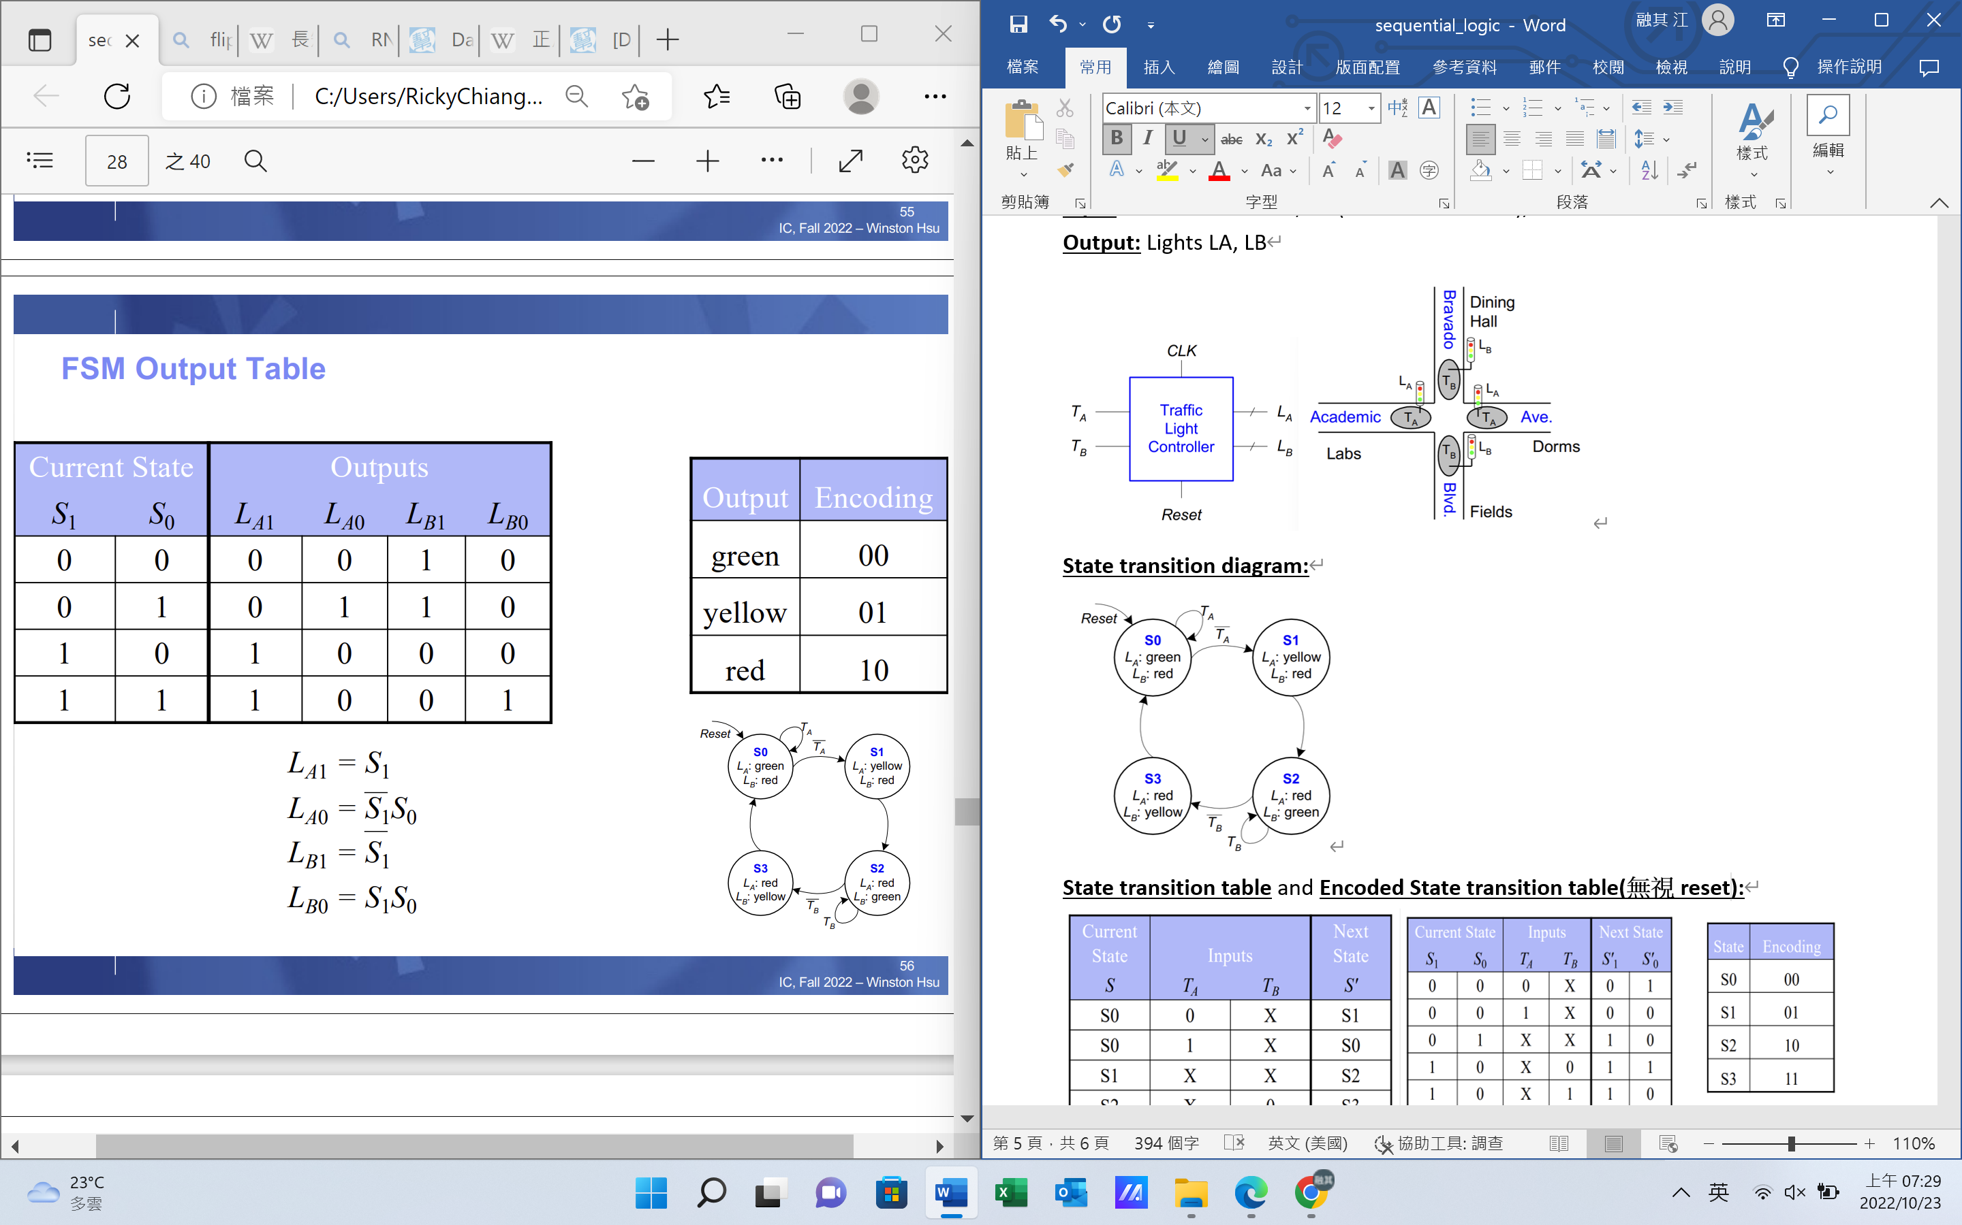

Using **Encoded State transition table** and **Output table** to draw the  
**FSM schematic:**

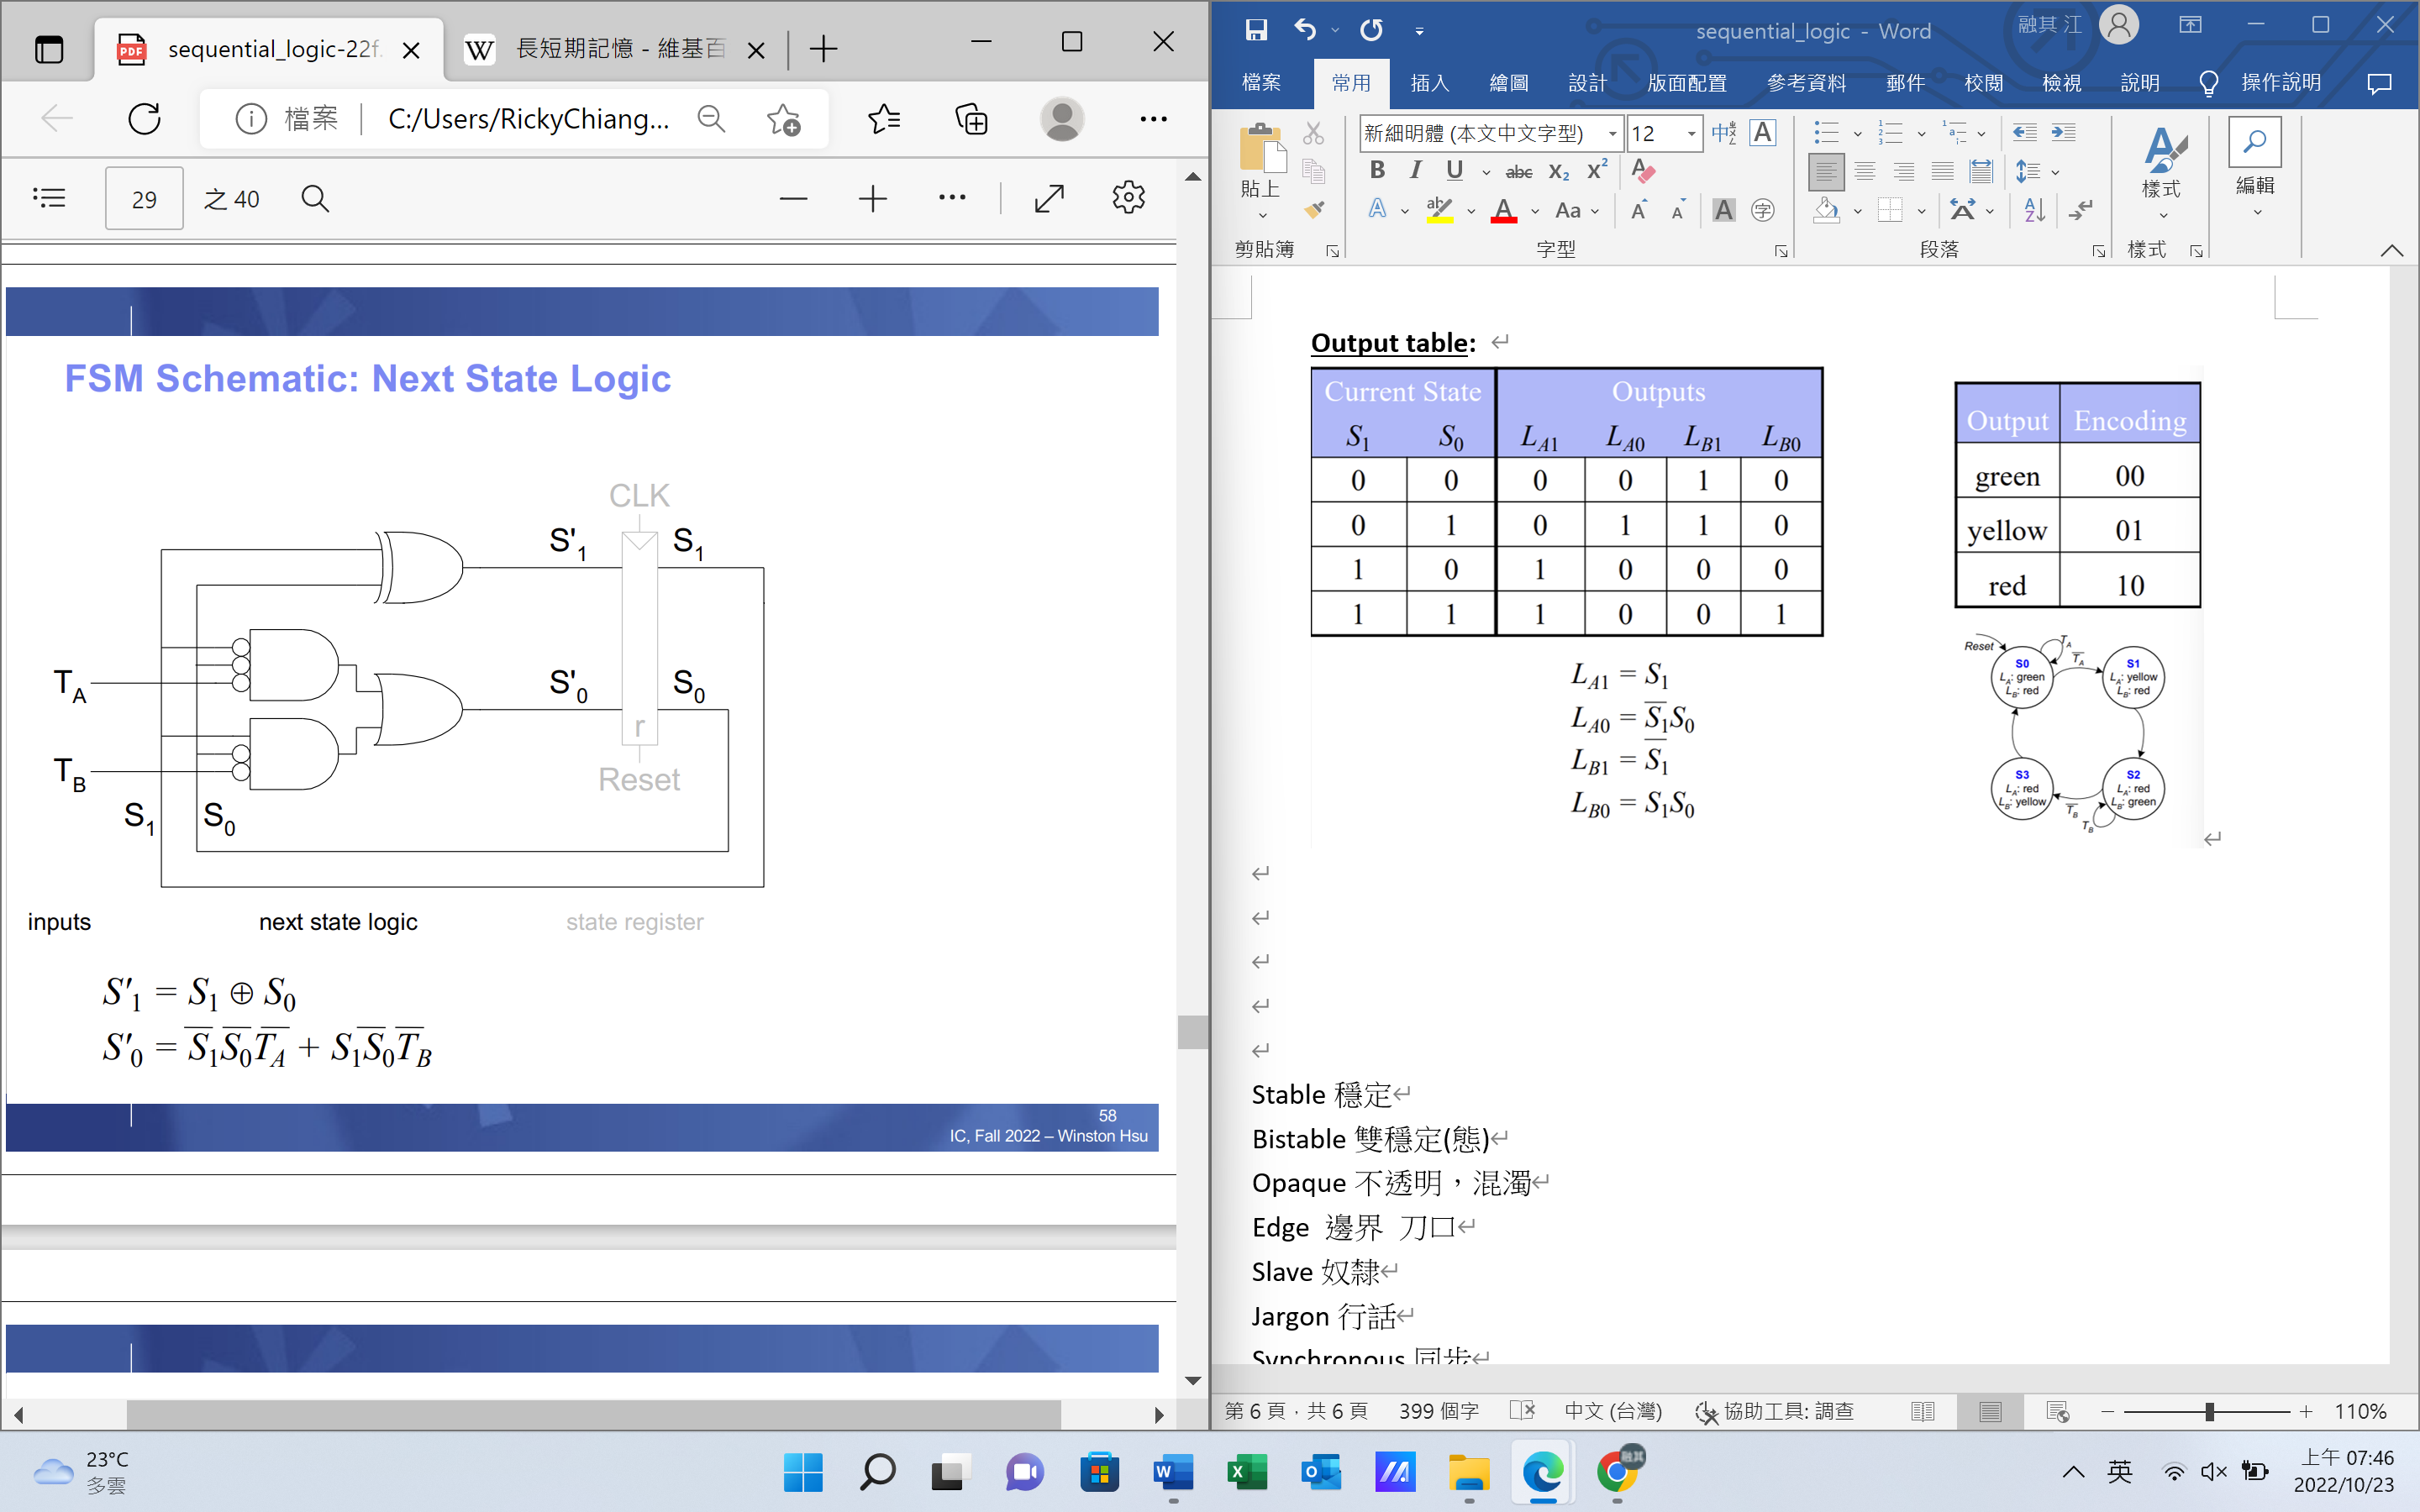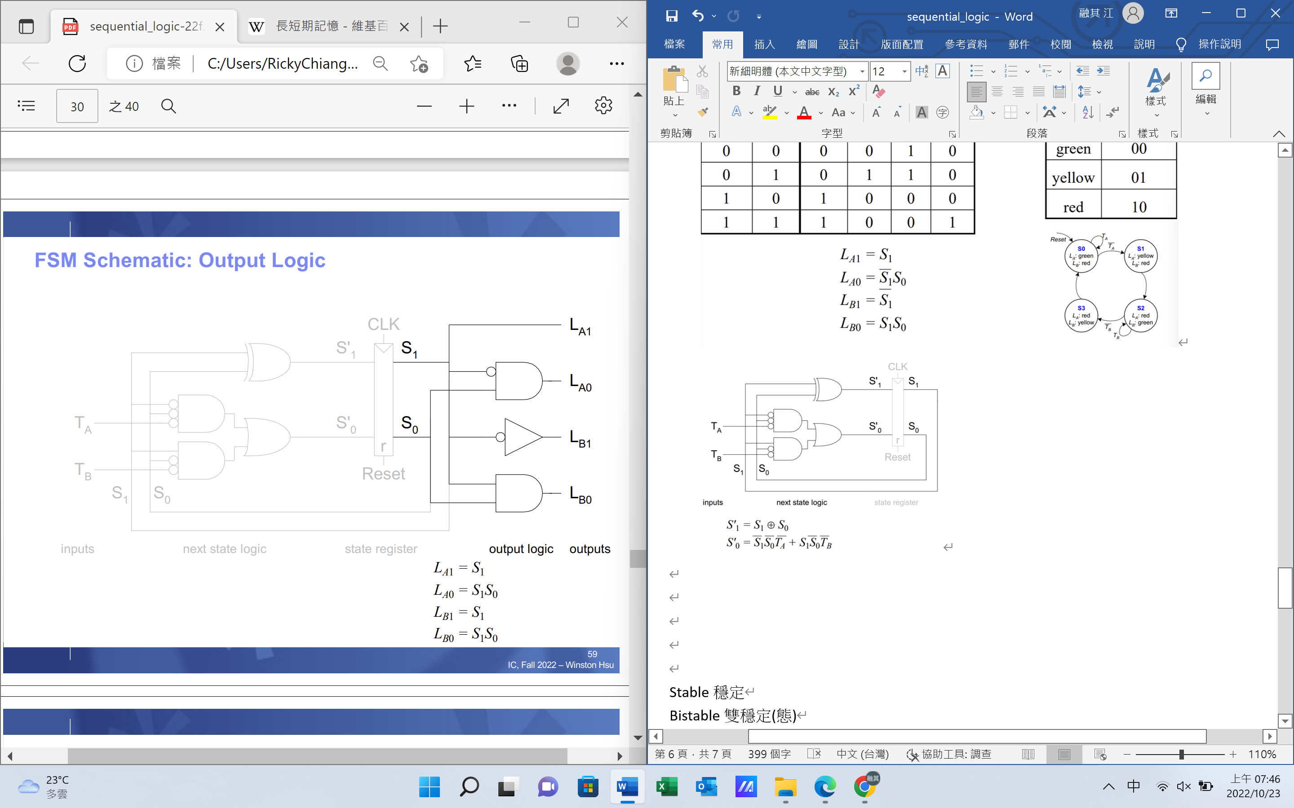

**FSM timing diagram**:

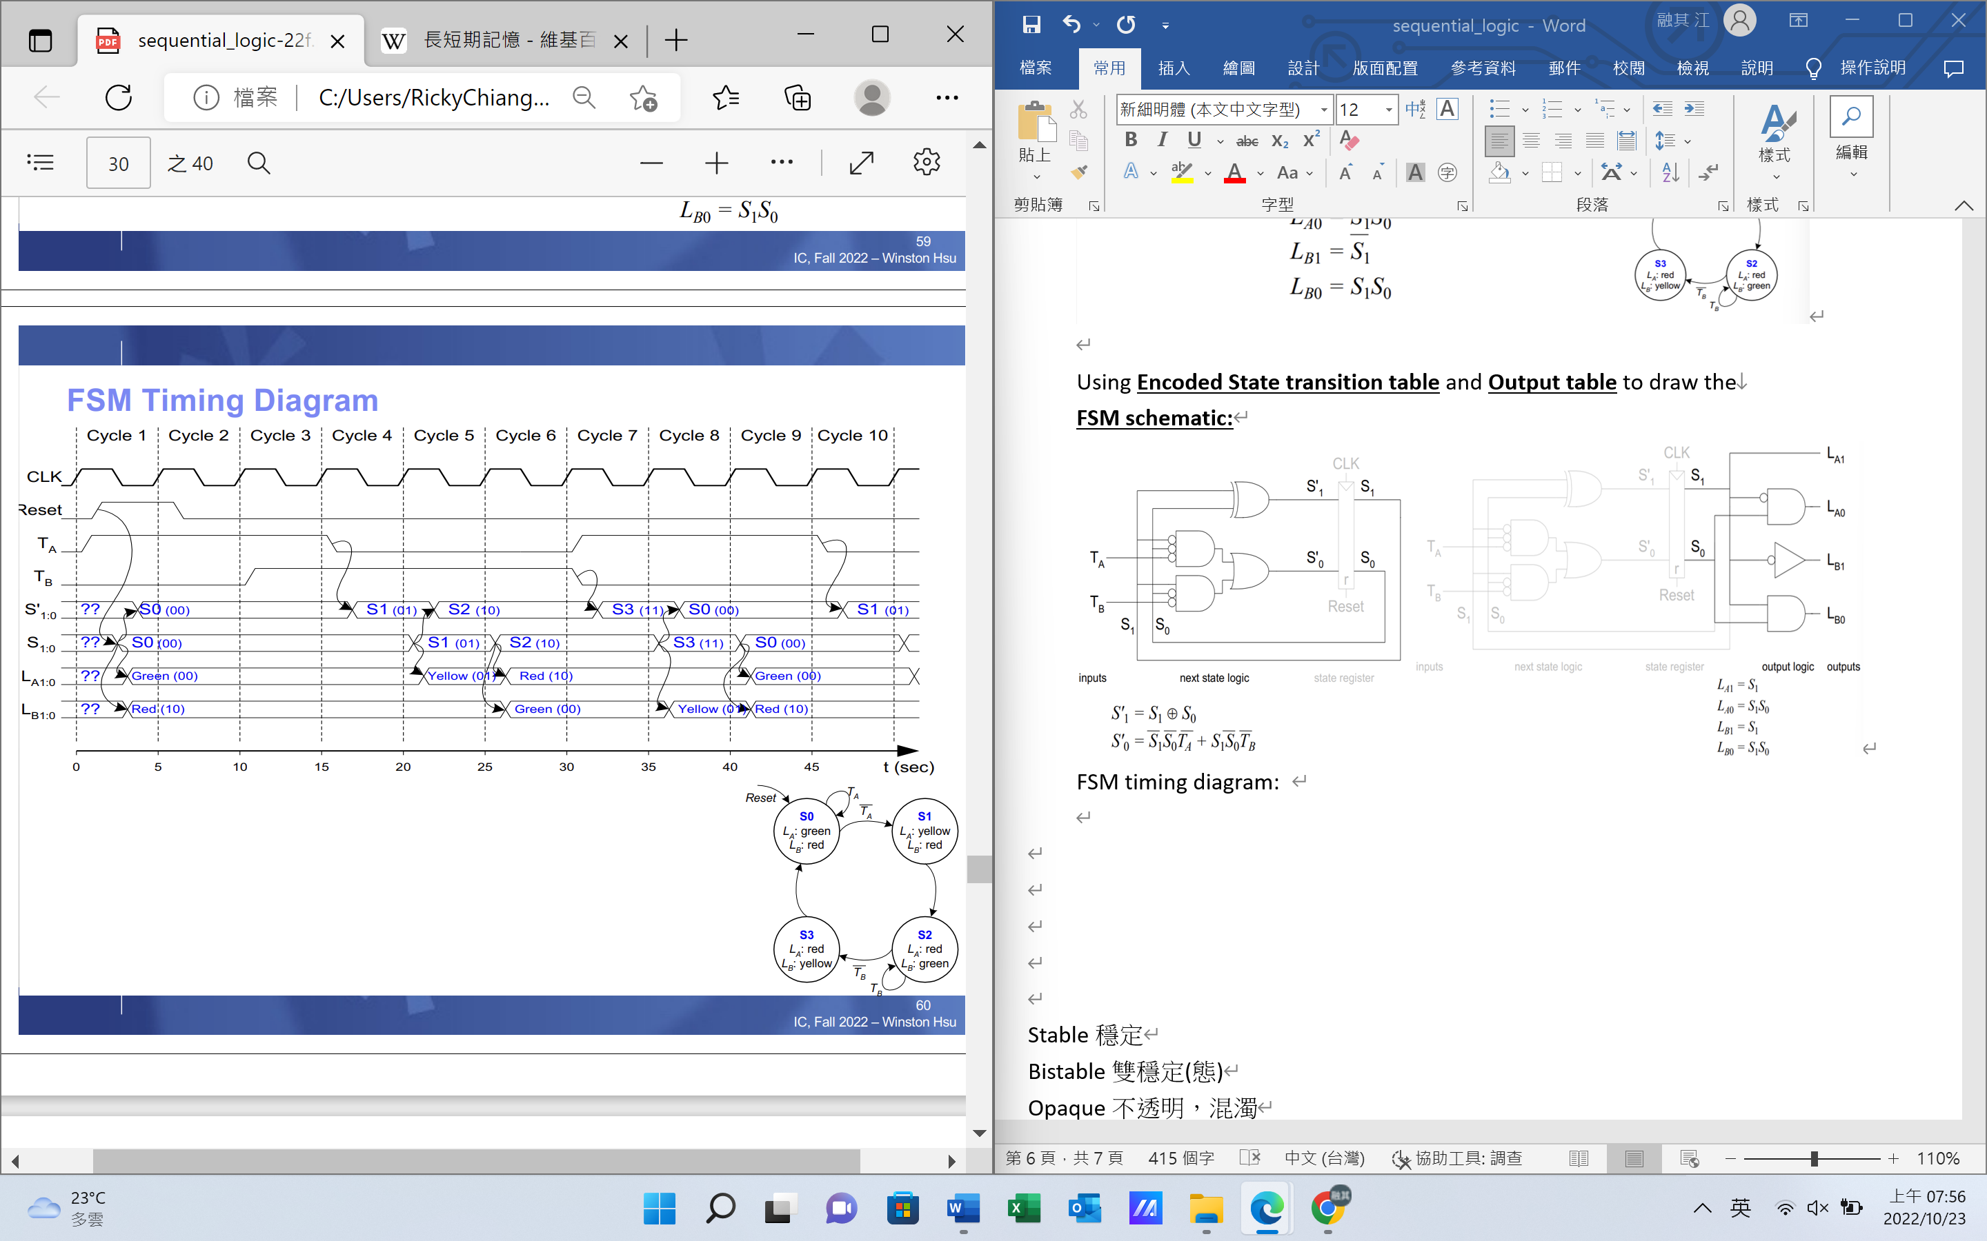

* FSM State Encoding: Binary(00, 01, 10, 11) or One-hot(0001, 0010, 0100, 1000), one hot is simpler but cost more flip-flops
* Moore vs. Mealy: example「01 snail smile」

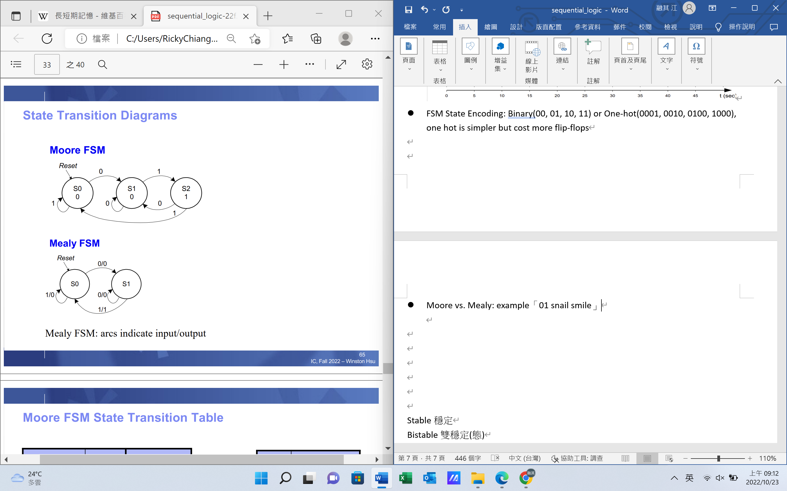 

Moore **State Transition Table** and **output table**:

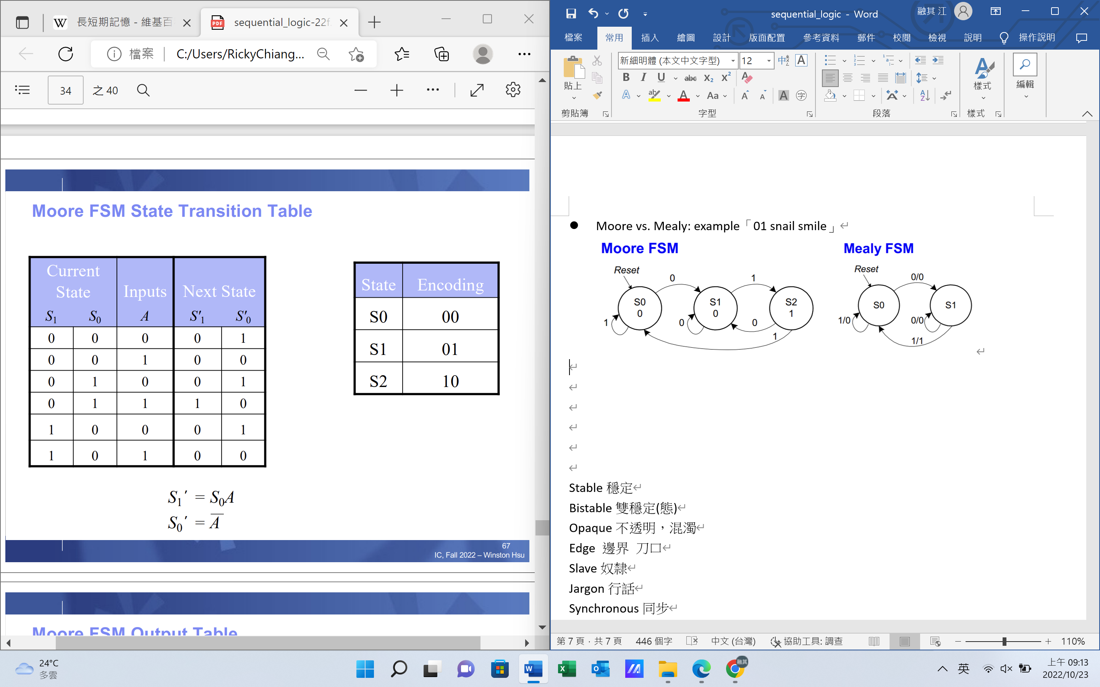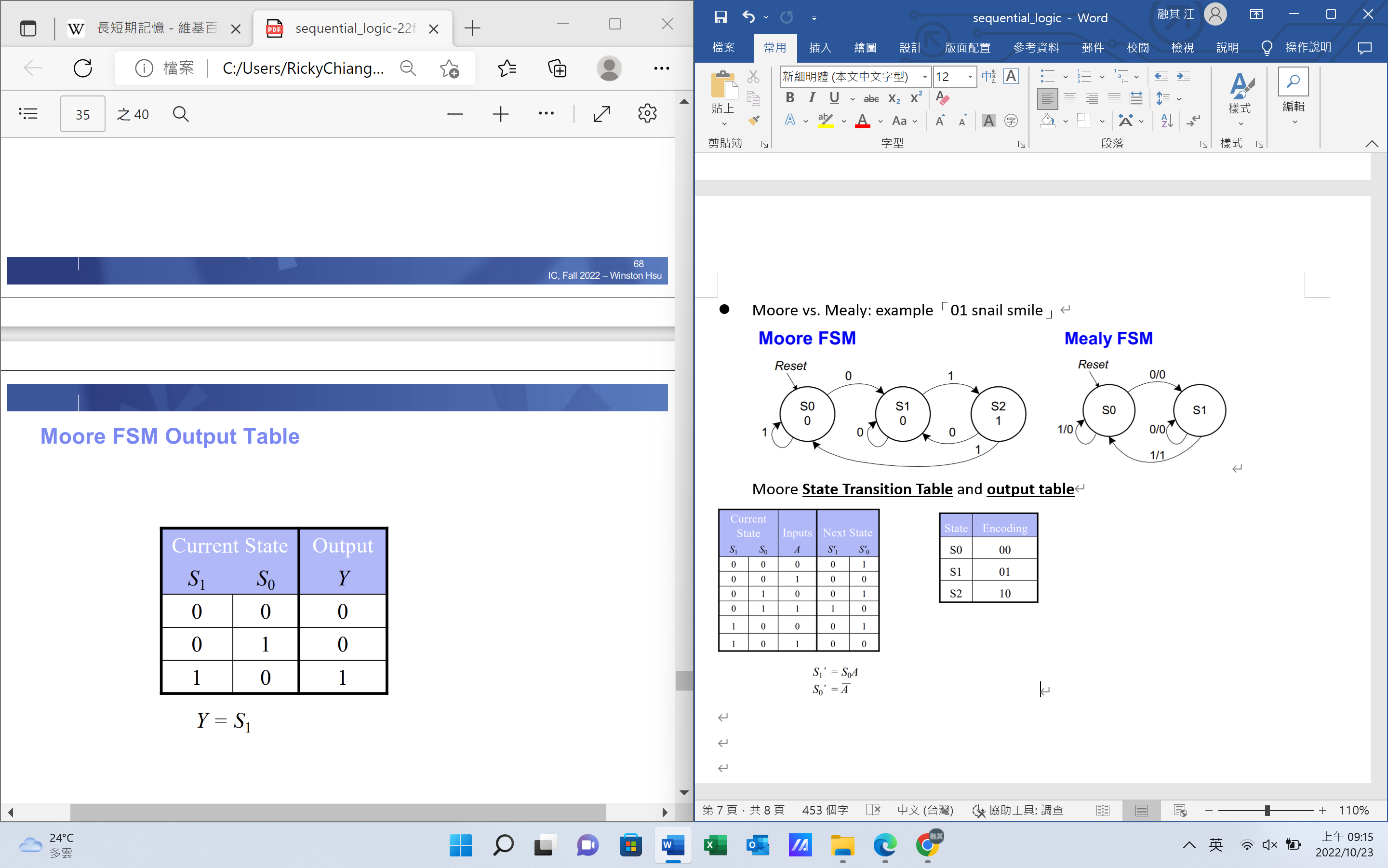

Mealy **State Transition Table** and **output table**:

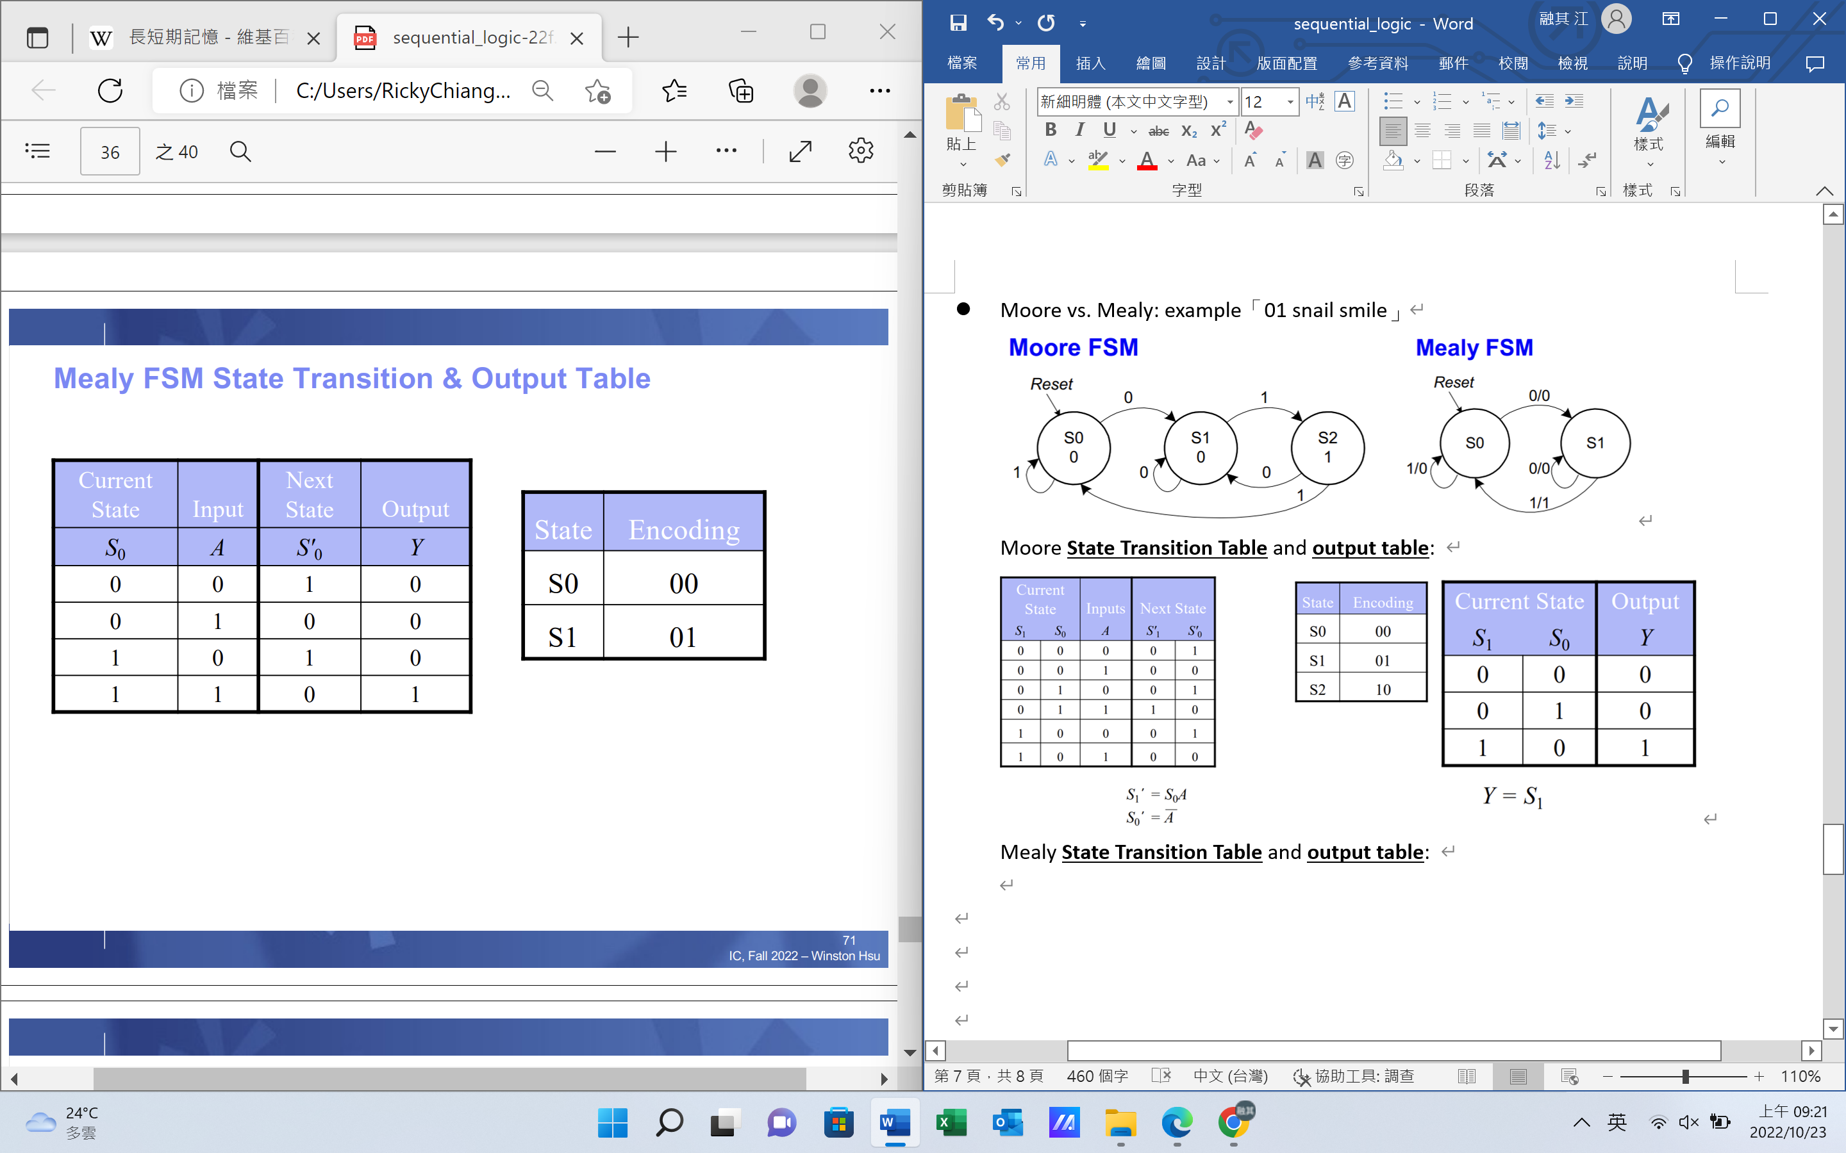

**Schematic: 由table來畫Moore, Mealy(注意S在後, S’在前)**

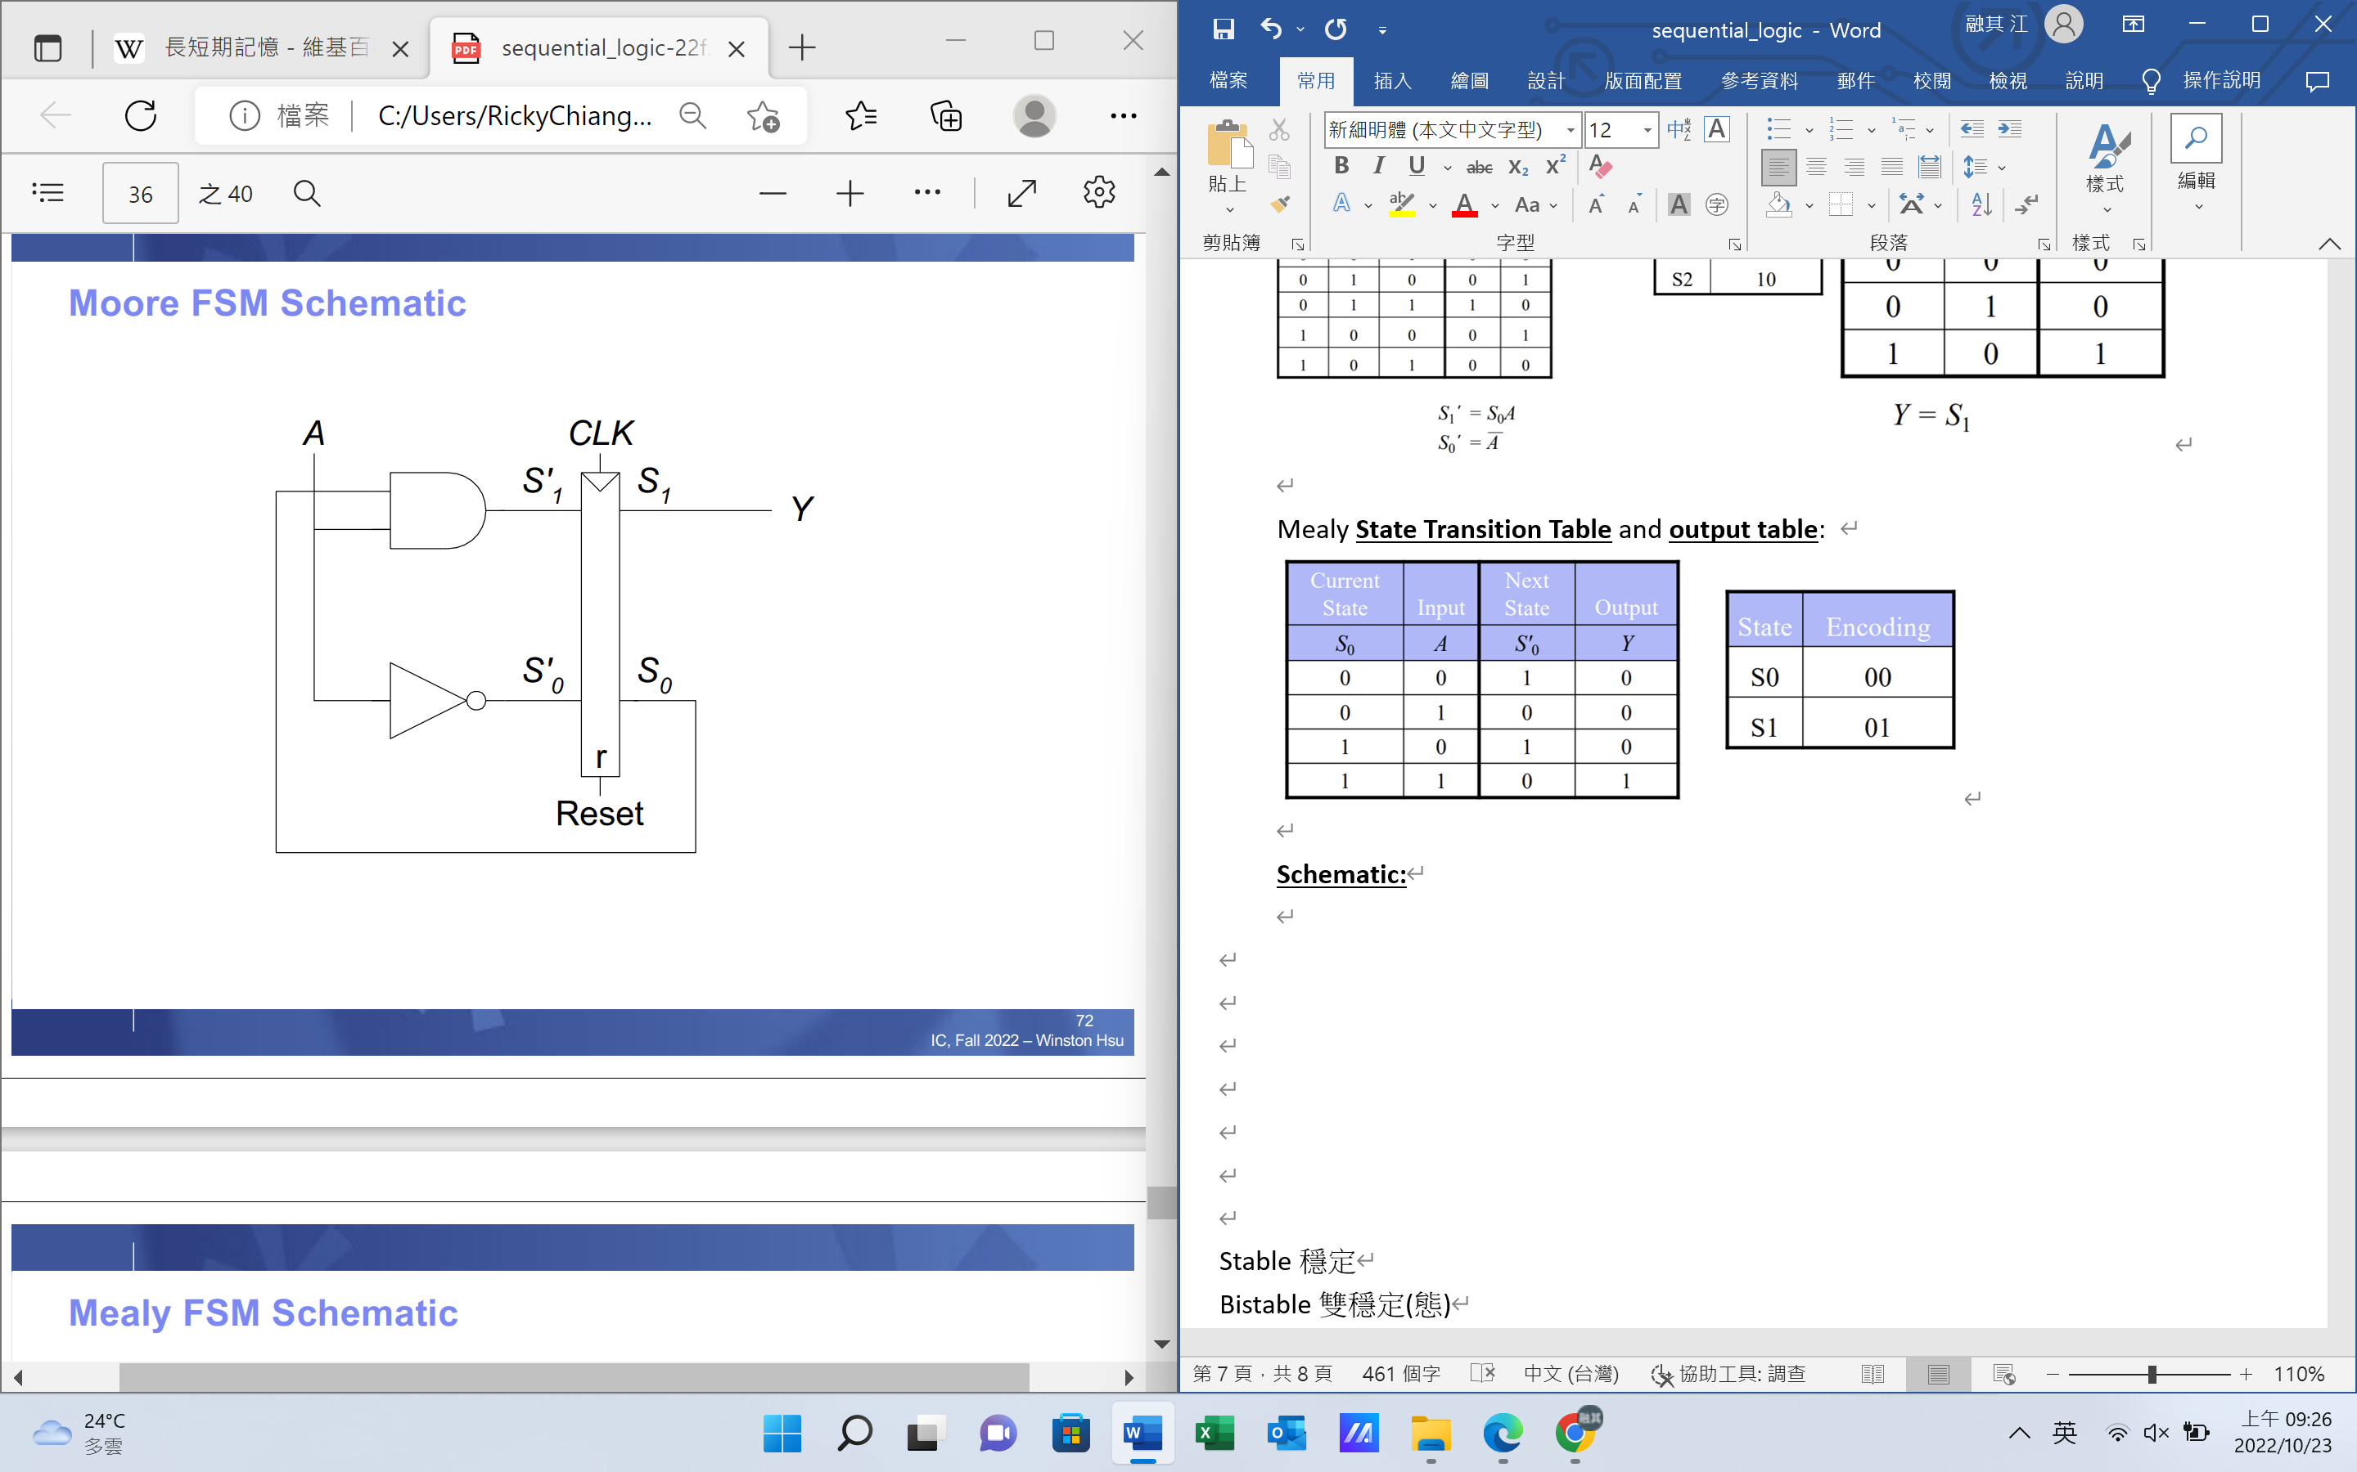 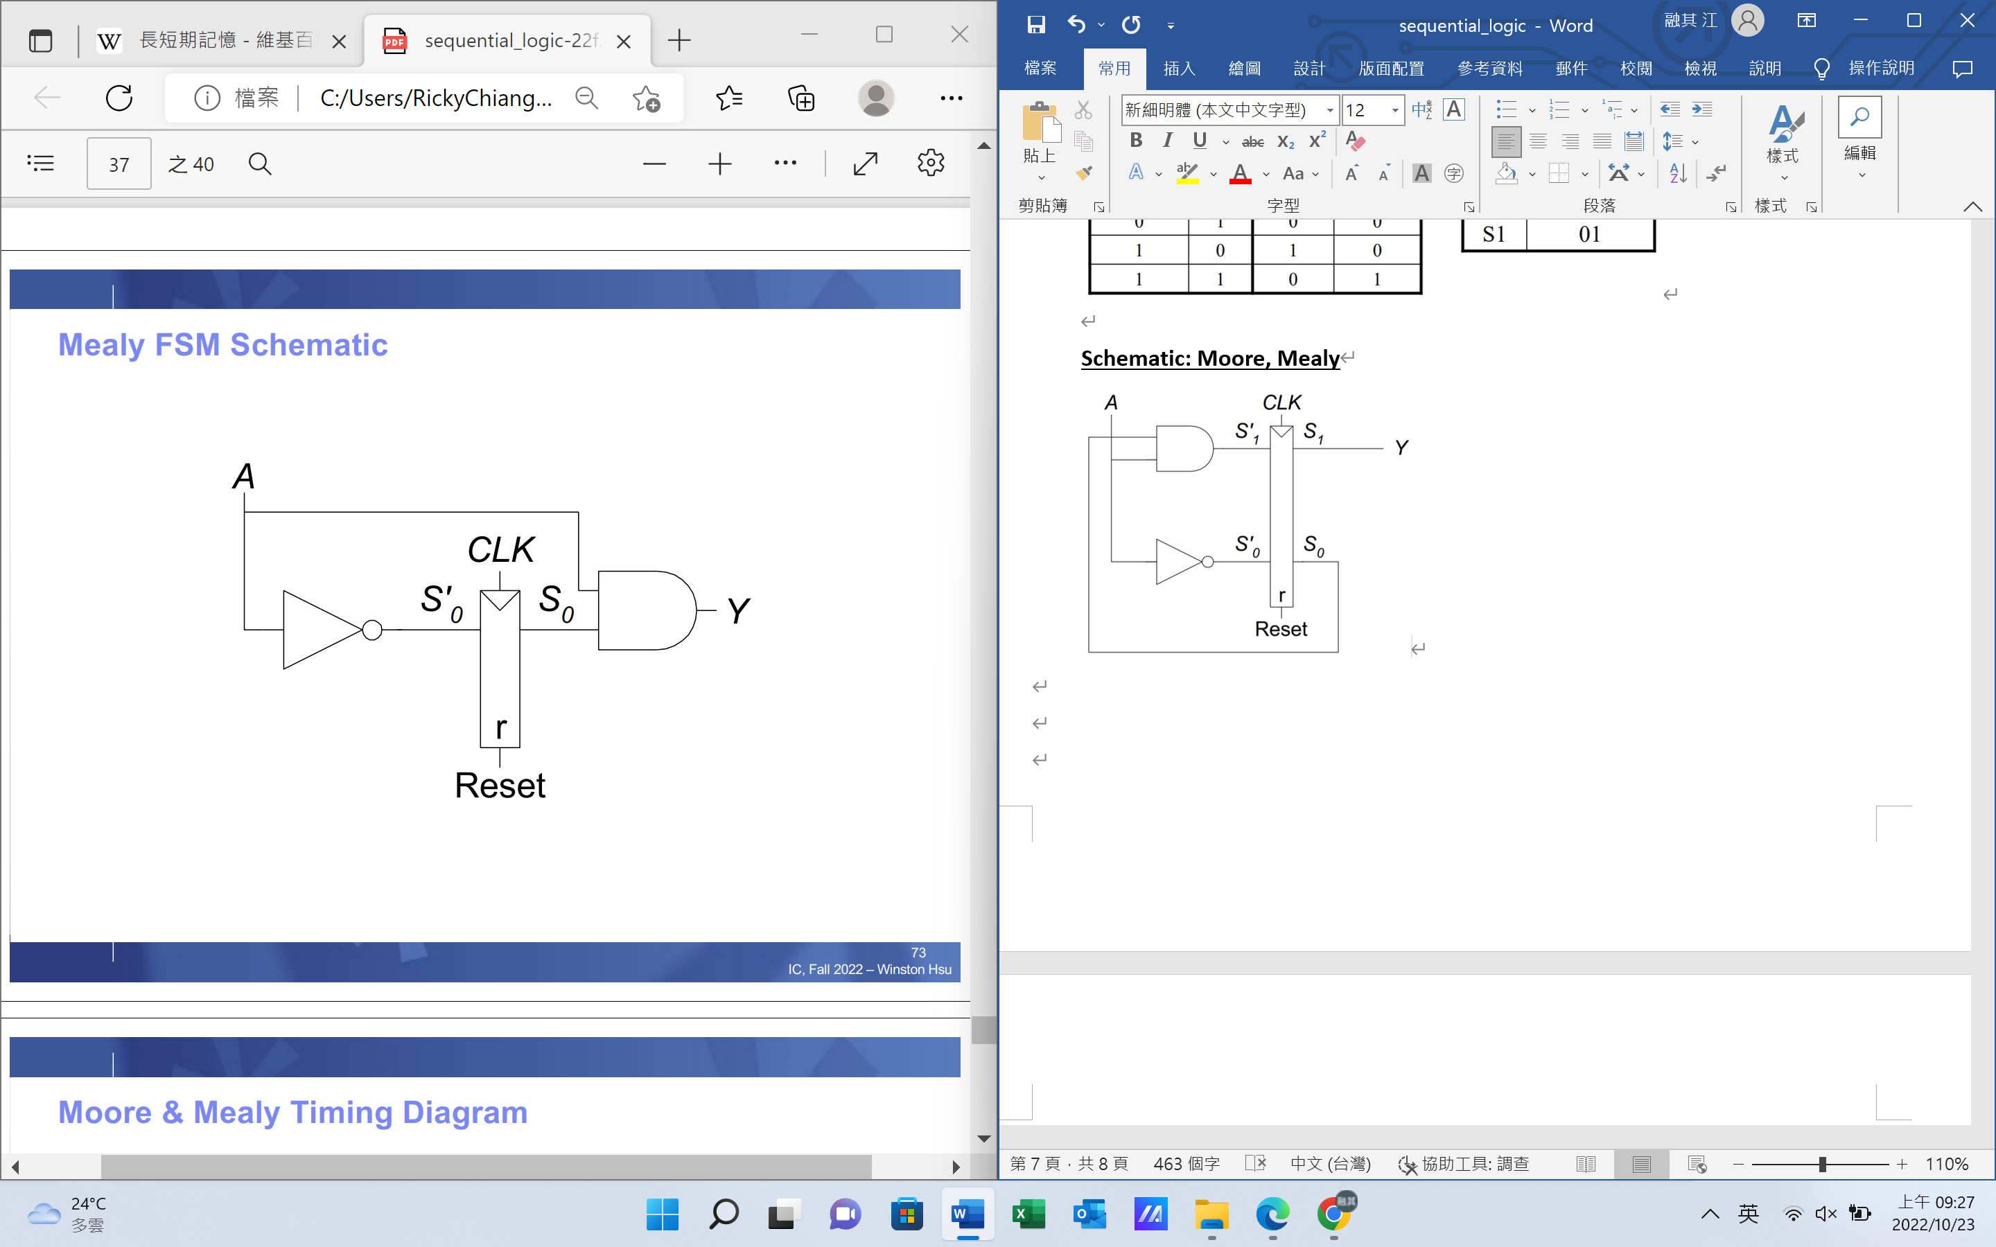

**Timing Diagram:**

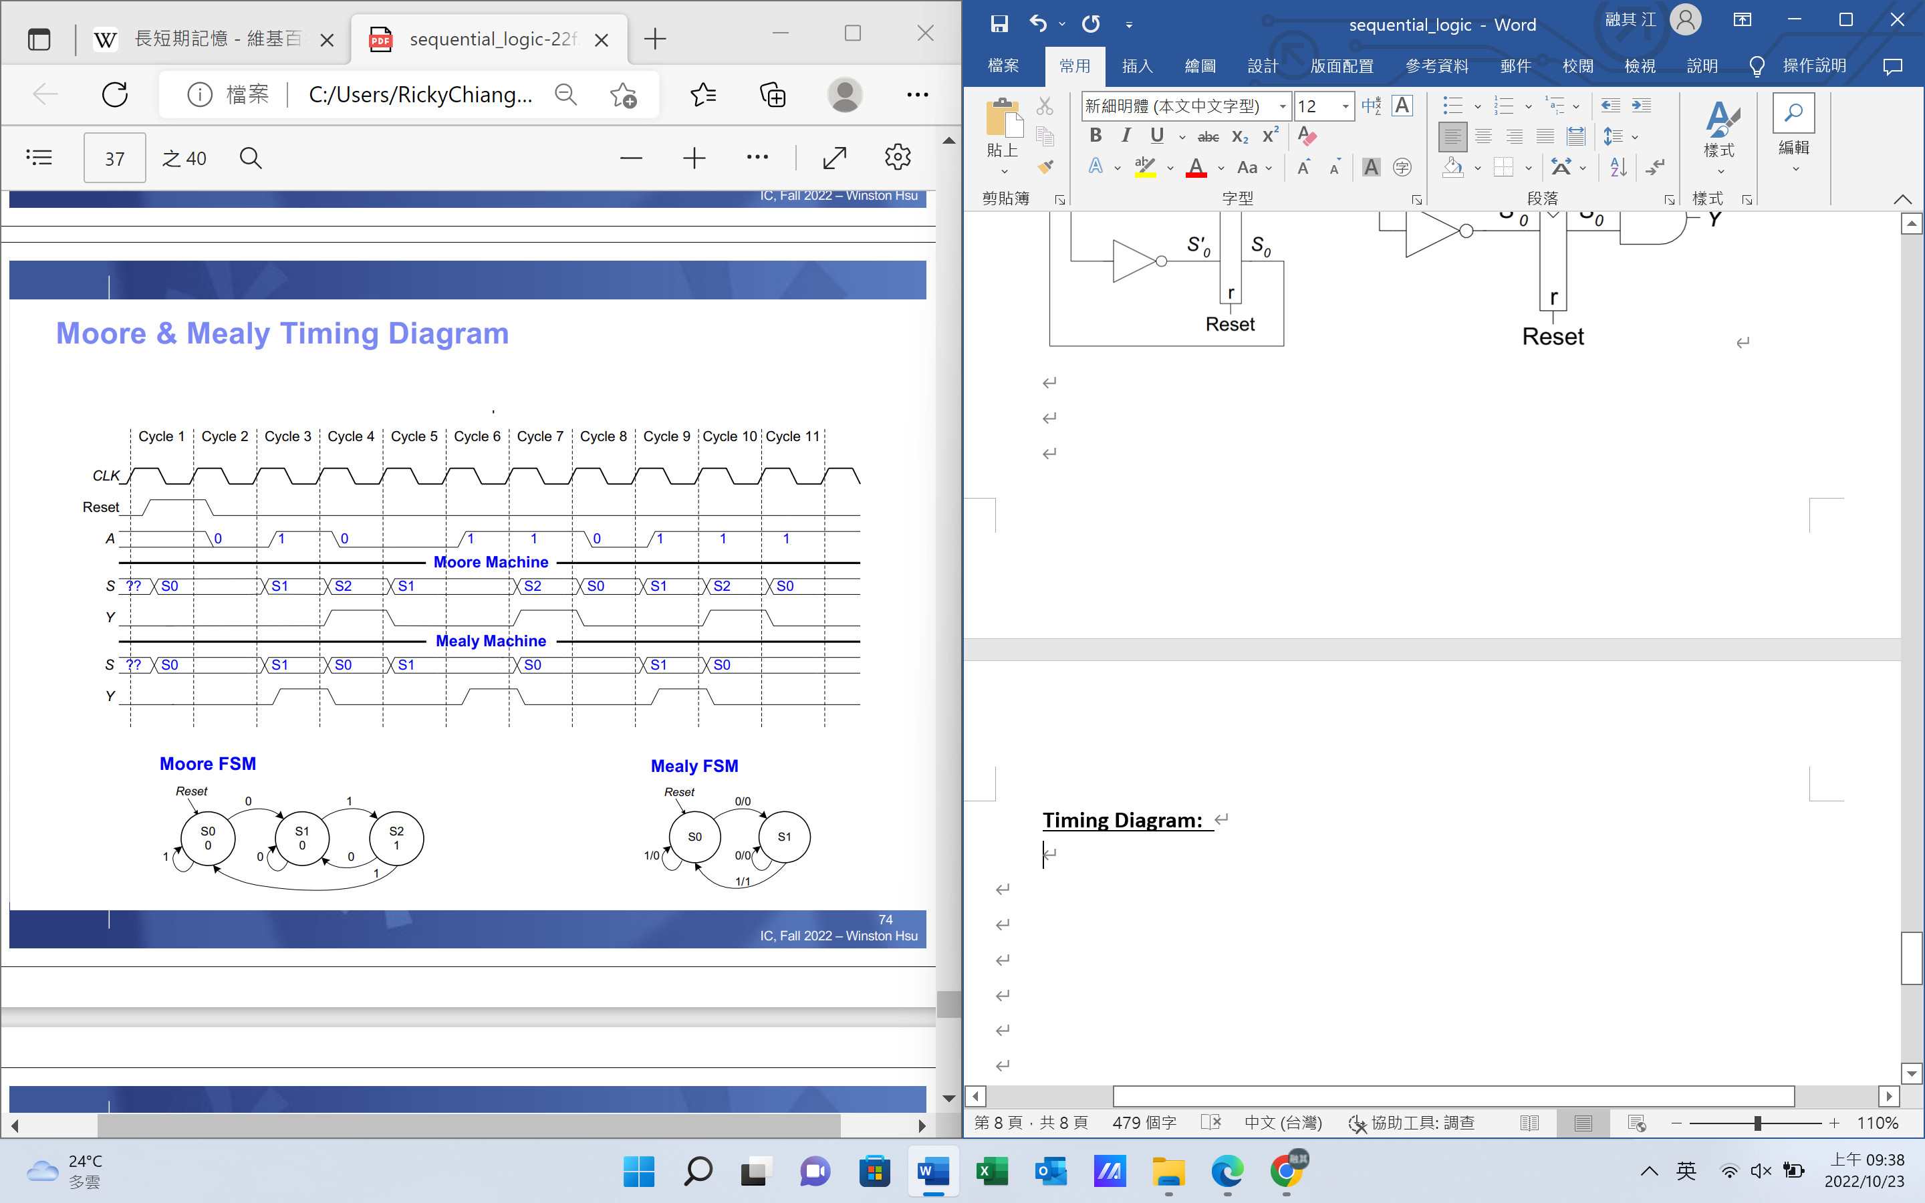

* **Factoring State Machines (FSMs)**

Example: modify traffic light controller ro have Parade Mode

Stable穩定

Bistable雙穩定(態)

Opaque不透明，混濁

Edge 邊界 刀口

Slave奴隸

Jargon行話

Synchronous同步

Asynchronous 異步

Immediately 馬上

Anatomy剖析

Recursive遞迴的

Interface介面 接口

Either or非此即彼

Neither nor非此非彼

Current當前的

Derive推導出

Synthesize合成

Schematic 圖解